Lab 10: EXE With Trojan Code in a New Section

**Huynh Ngoc Quang – SE181838**

**Task 1: Add a Section with LordPE**

**Copying putty.exe**

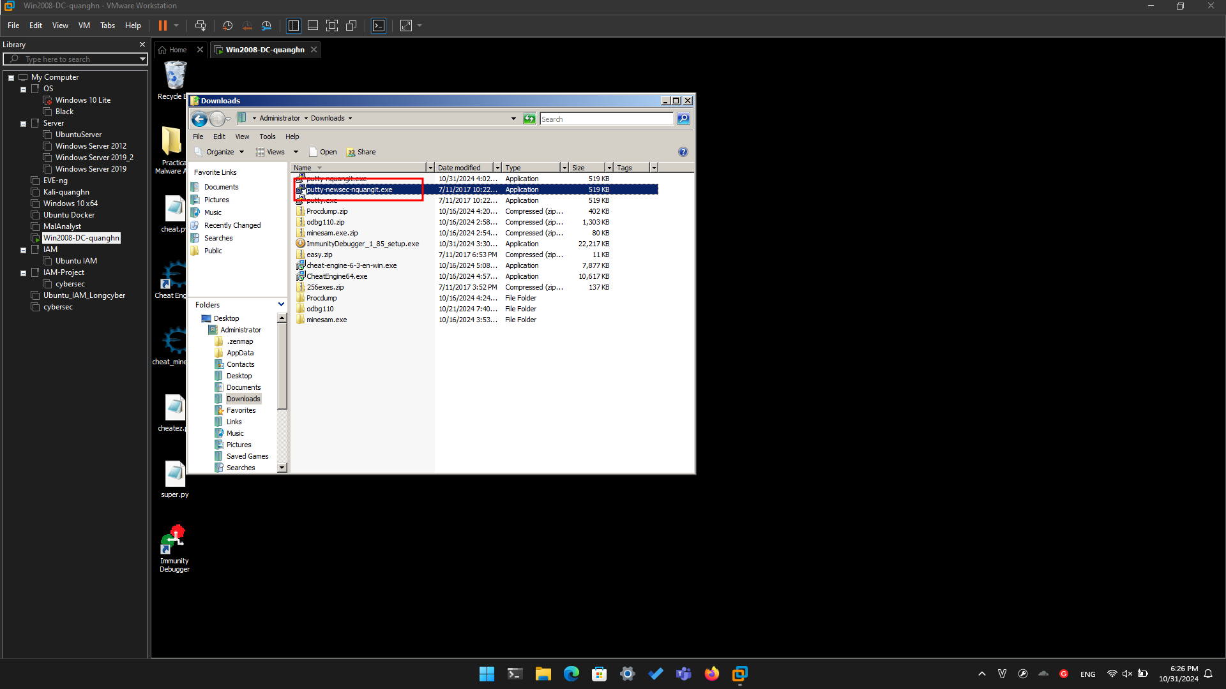

**Getting LordPE**

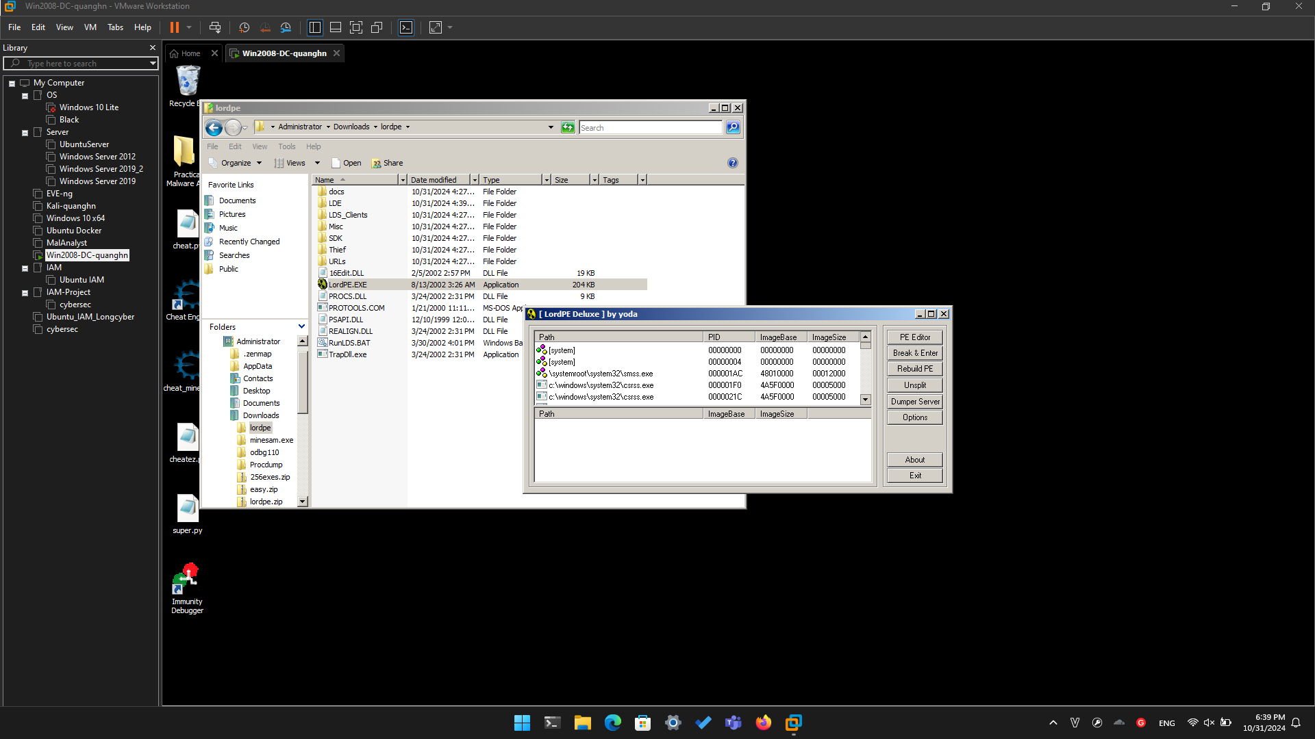

**Adding a New Section to the PE Header**

In the LordPE window, on the right side, click the "**PE Editor**" button.

In the Open box, navigate to **putty-newsec-YOURNAME.exe** and double-click it.

A "PE Editor" box opens, showing general information about putty, as shown below.

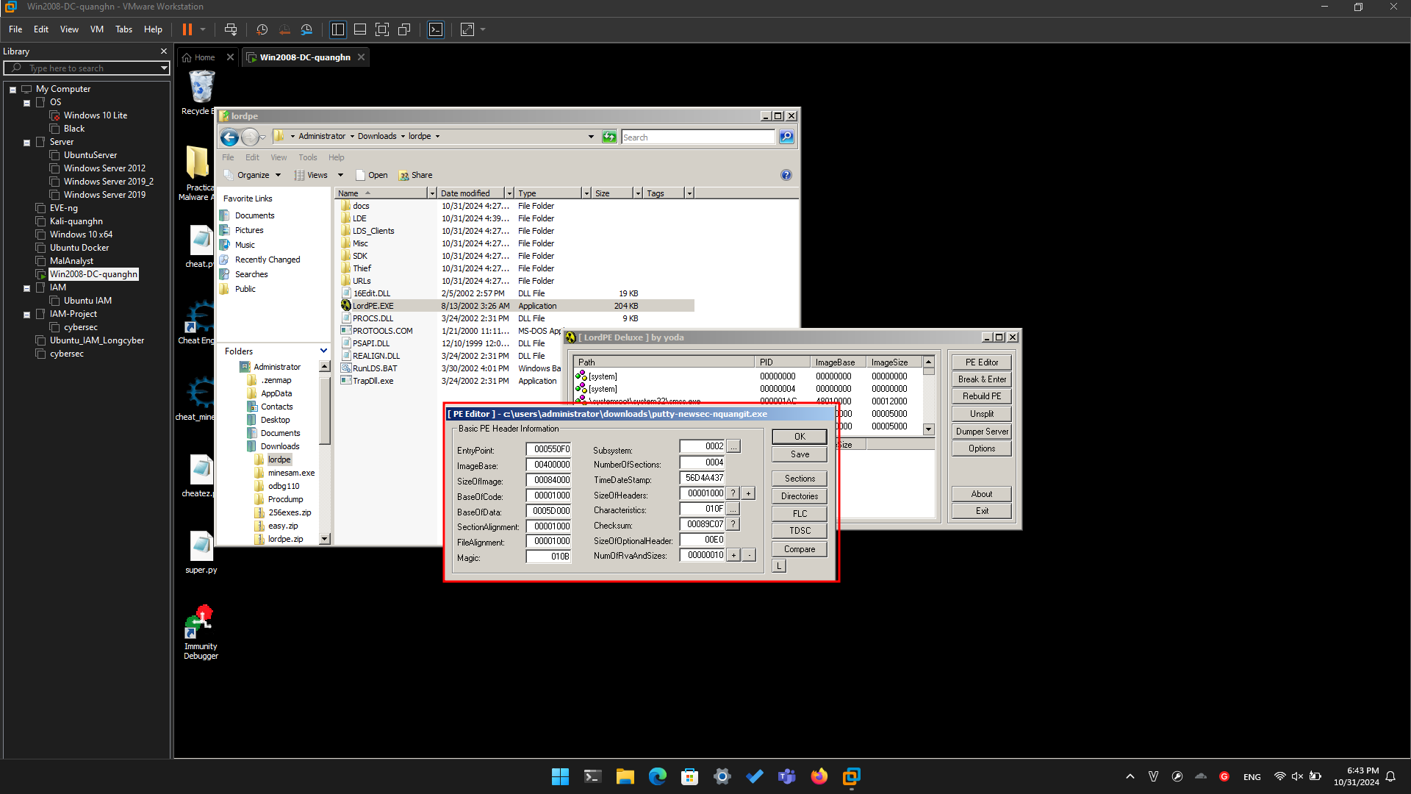

In the "PE Editor" box, on the right, click the **Sections** button.

A "Section Table" box opens, showing the four sections in the putty executable.

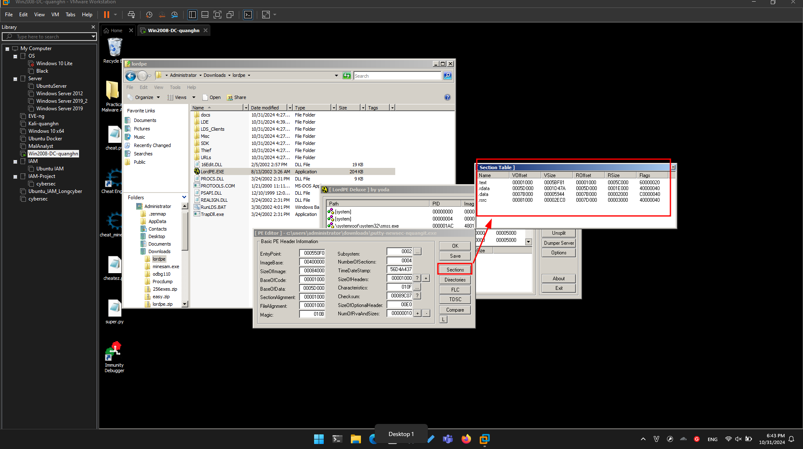

Right-click one of the sections and click "**add section header**", as shown below.

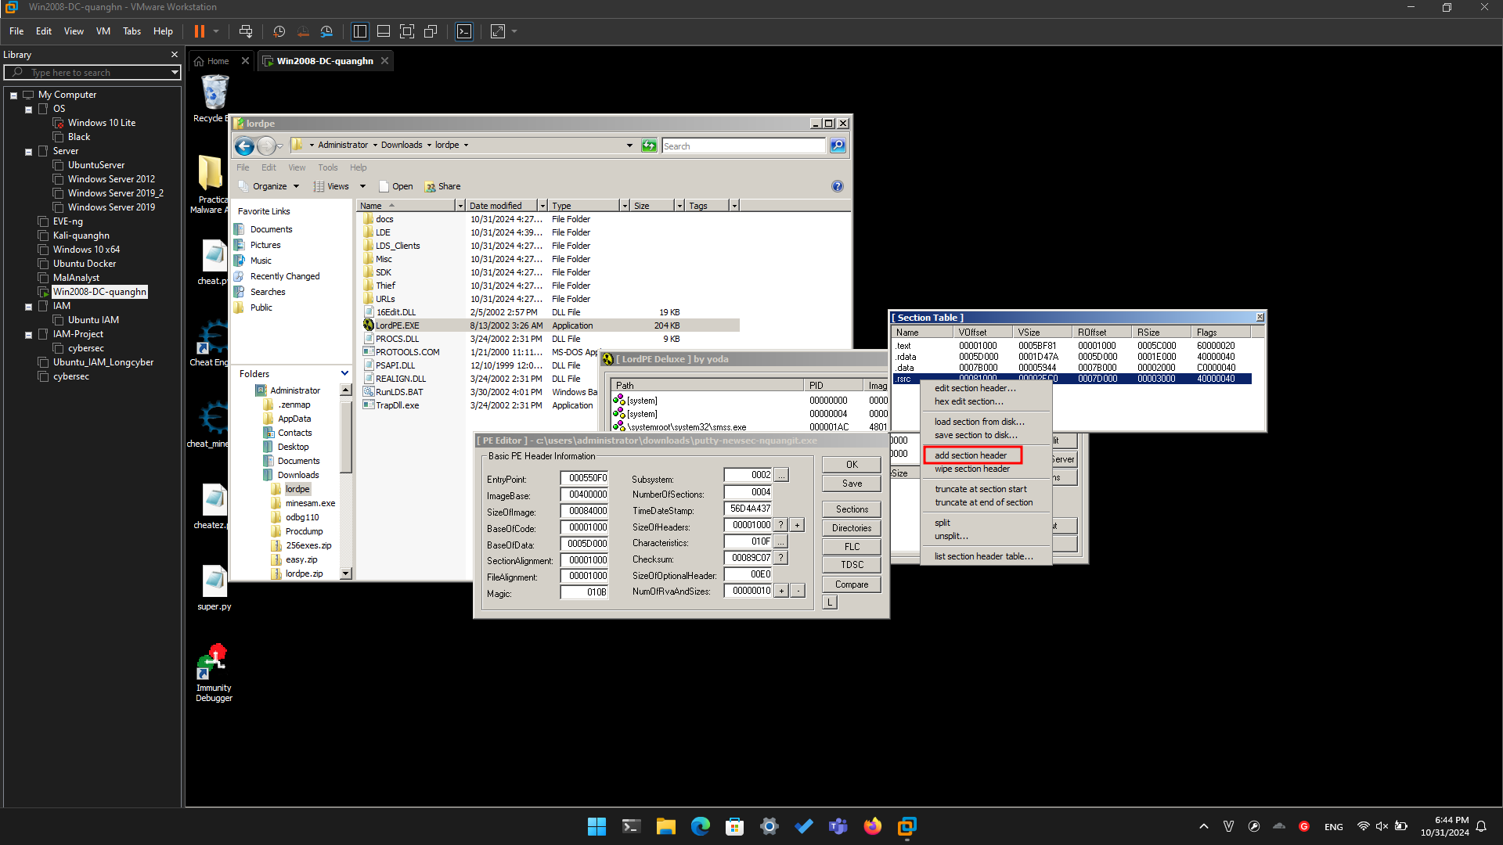

A new section named "NewSec" appears. Currently, this section has "VSize" and "RSize" values of 0, as shown below.

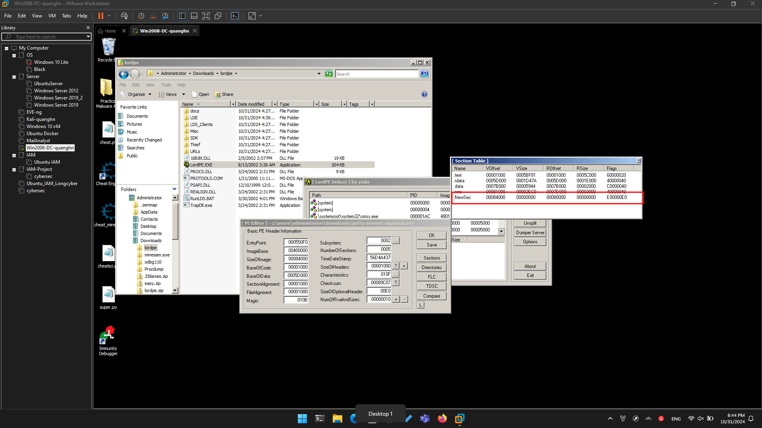

In the "Section Table" box, right-click **NewSec** and click "**edit section header**".

In the "[Edit SectionHeader]" window, change the **VirtualSize** and **RawSize** to **00001000** as shown below.

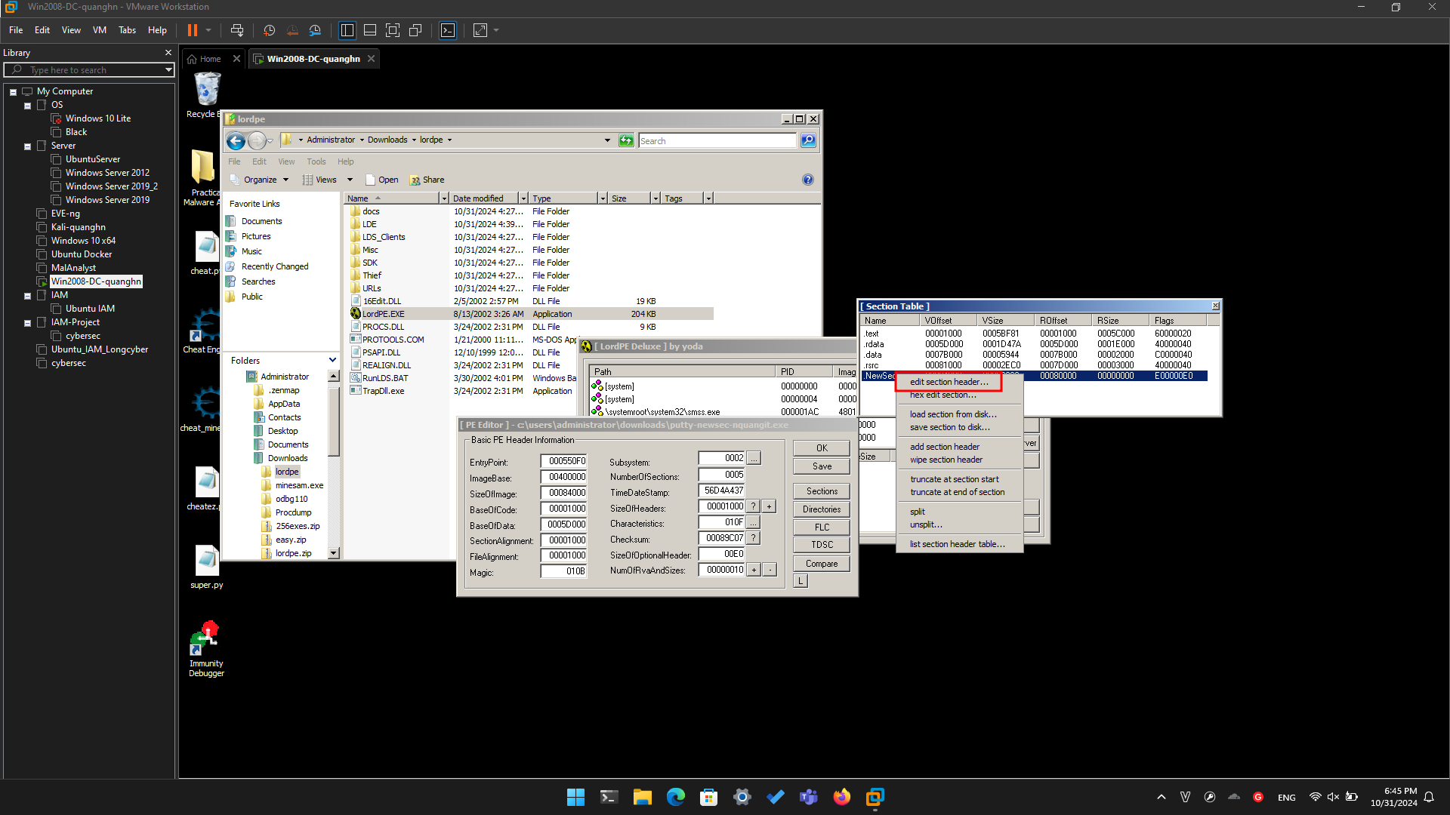

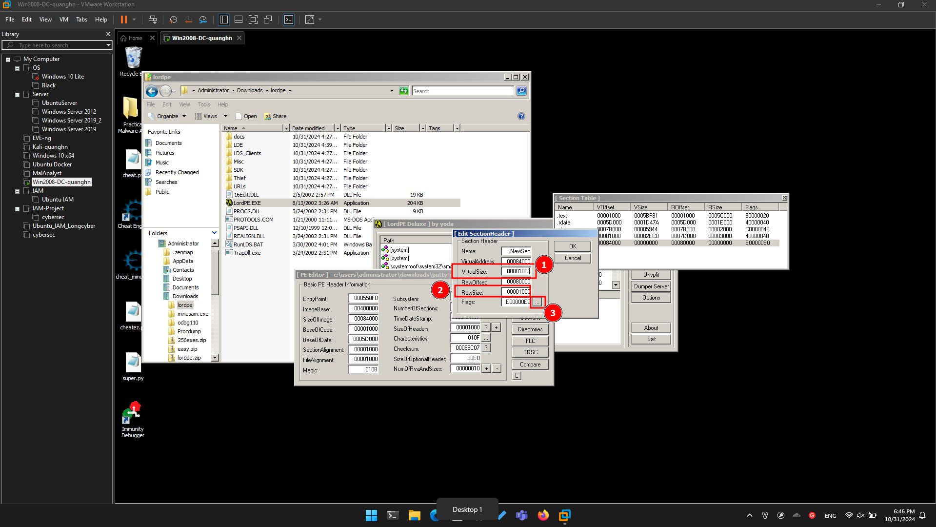

In the "[Edit SectionHeader]" window, at the bottom, in the "Flags" row, click the square button labelled **...**.

Note the top three check boxes here: this segment is Executable, Readable, and Writeable. That's good; we can place any type of code we want to here, even self-modifying code.

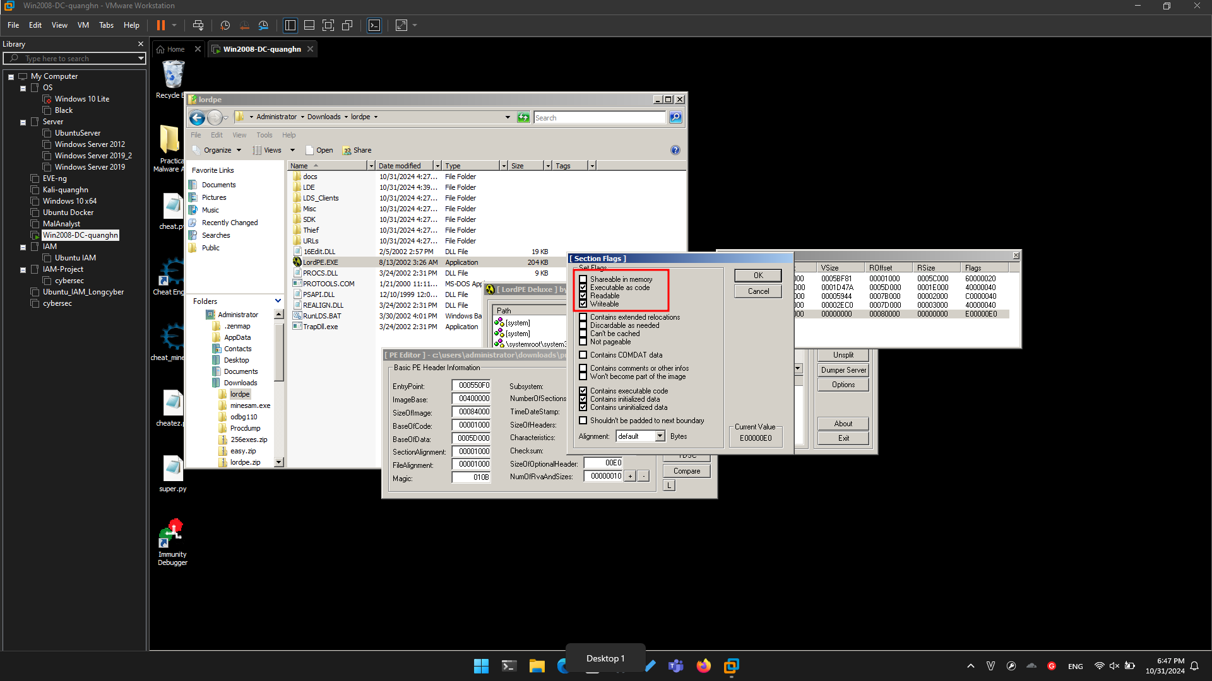

Click **OK**.

Click **OK**.

Close the "Section Table" box.

In the "PE Editor" box, click the **Save** button.

In the "PE Editor" box, click the **OK** button.

Close the LordPE window.

**Task 2: Redirecting Code Execution with Immunity**

**Using Immunity to Examine the NewSec Section**

Click **Start**. Search for **Immunity Debugger** and start it.

In Immunity, from the menu bar, click **File**, **Open**. Navigate to **putty-newsec-YOURNAME.exe** and open it.

From the Immunity menu bar, click **View**, **Memory**. as shown below.

Immunity shows the memory layout of putty. As outlined in blue in the image below, the "NewSec" section begins at address **484000**.

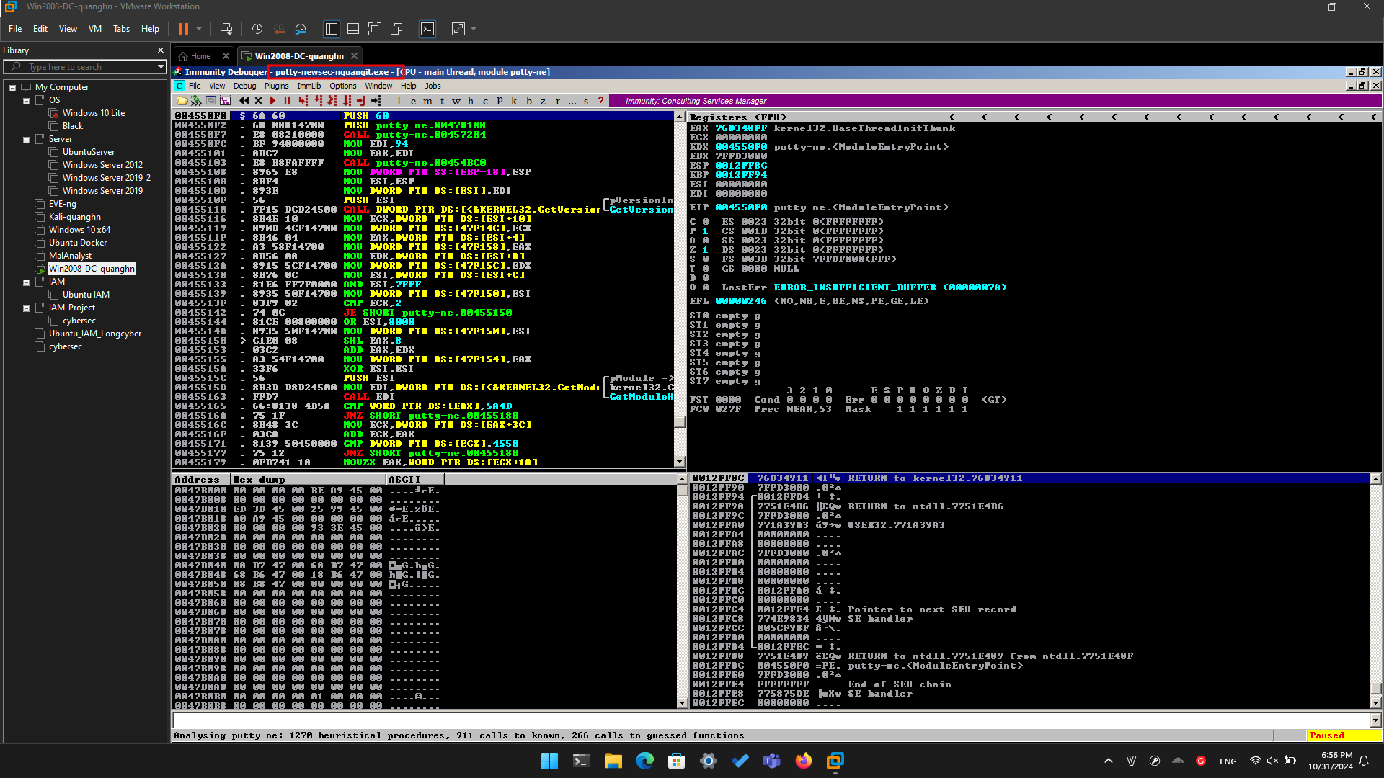

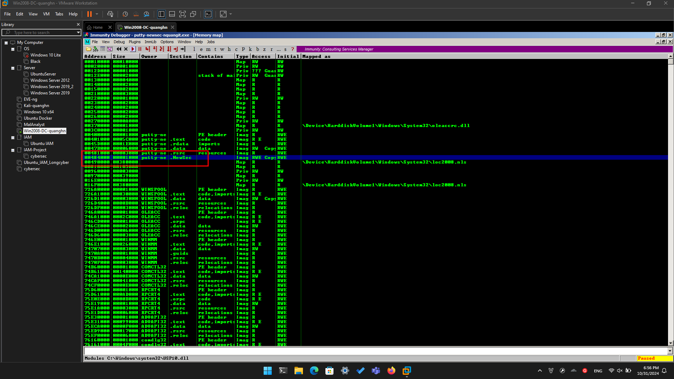

In the "Memory ma[" window, double-click **NewSec**.

A "Dump" window opens, showing the data stored in NewSec, as shown below.

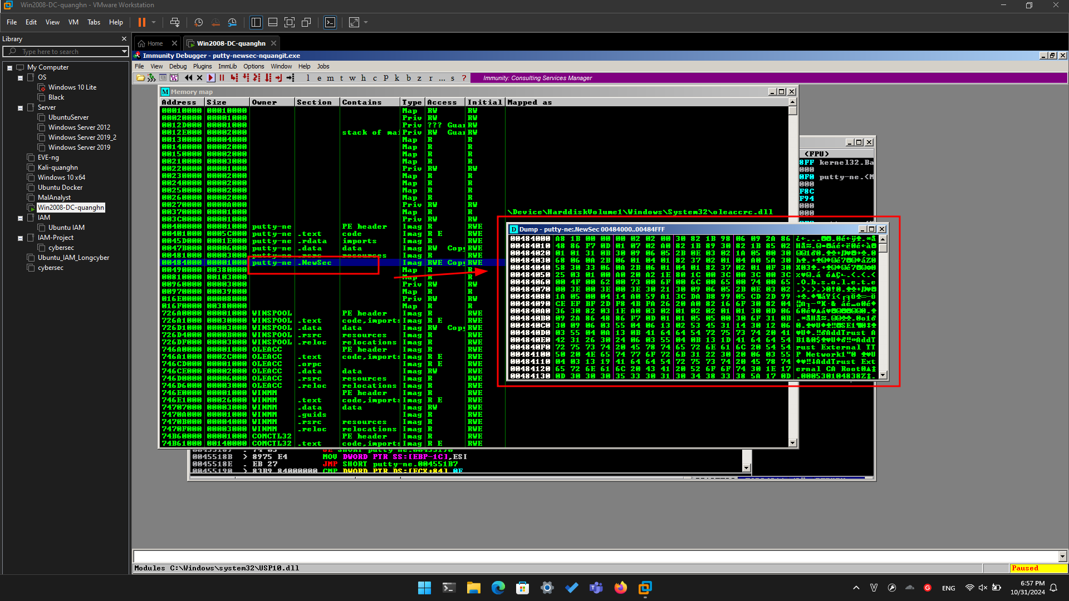

This is a digital signature, added to recent downloads of Putty. Notice the readable text in the lower portion of this window, on the right side, saying "AddTrust External CA Root".

The digital signature is a good way to verify file integrity, but it's not essential for file execution, so we can overwrite it.

Close the Dump window. Close the "Memory map" window.

**Using Immunity to Redirect Code Execution**

In Immunity, maximize the CPU window.

In the top left pane of the CPU window, right-click, and click "**Go to**", **Expression**, as shown below.

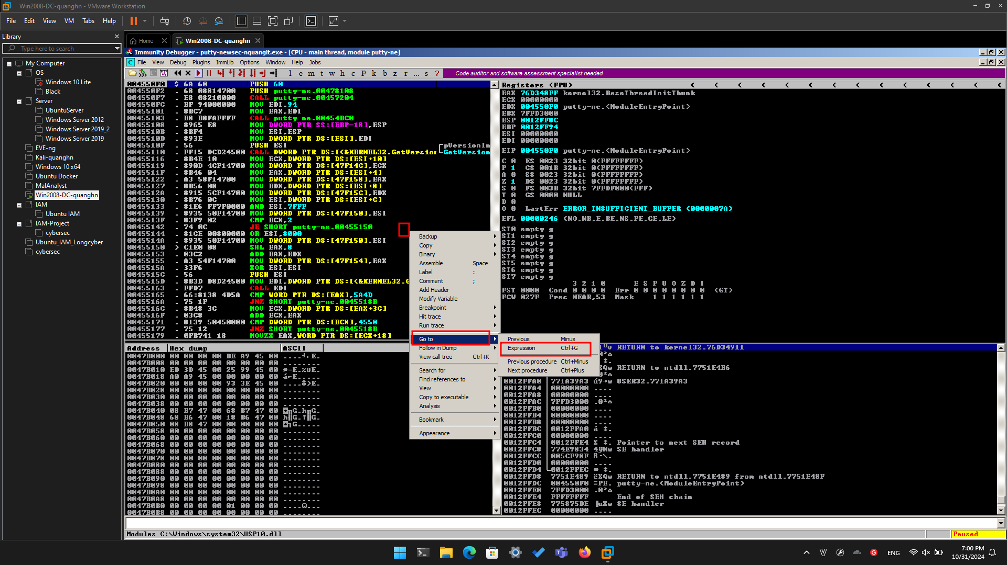

In the "Enter expression to follow" box, enter **41CB6E** as shown below. Click **OK**.

Immunity moves to show the PUSH instruction that loads the "login as: " string, as shown below.

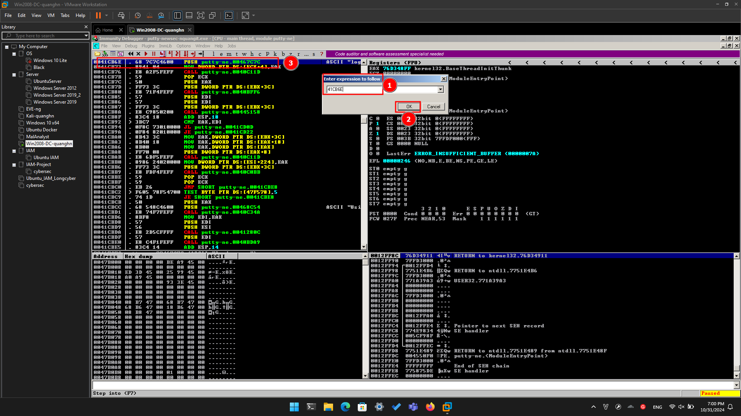

Right-click the **PUSH** instruction and click **Assemble**, as shown below.

In the "Assemble" box, enter this command:

**JMP 484000**

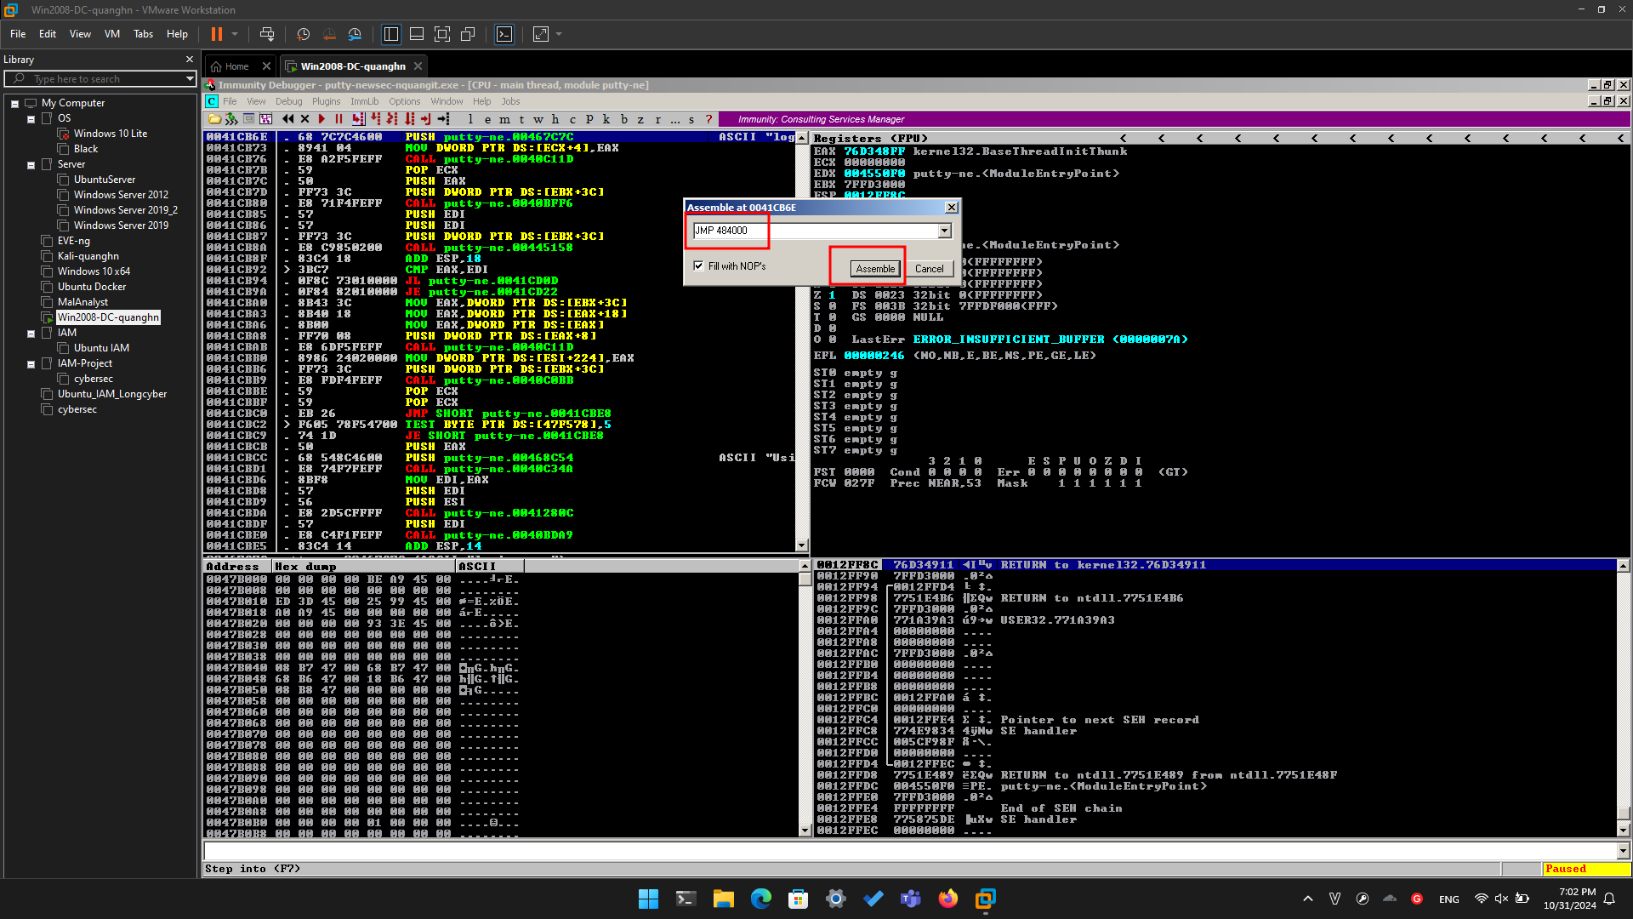

Click the **Assemble** button.

Click the **Cancel** button.

The MOV instruction has been replaced by this instruction, as shown below:

**JMP putty-ne.00484000**

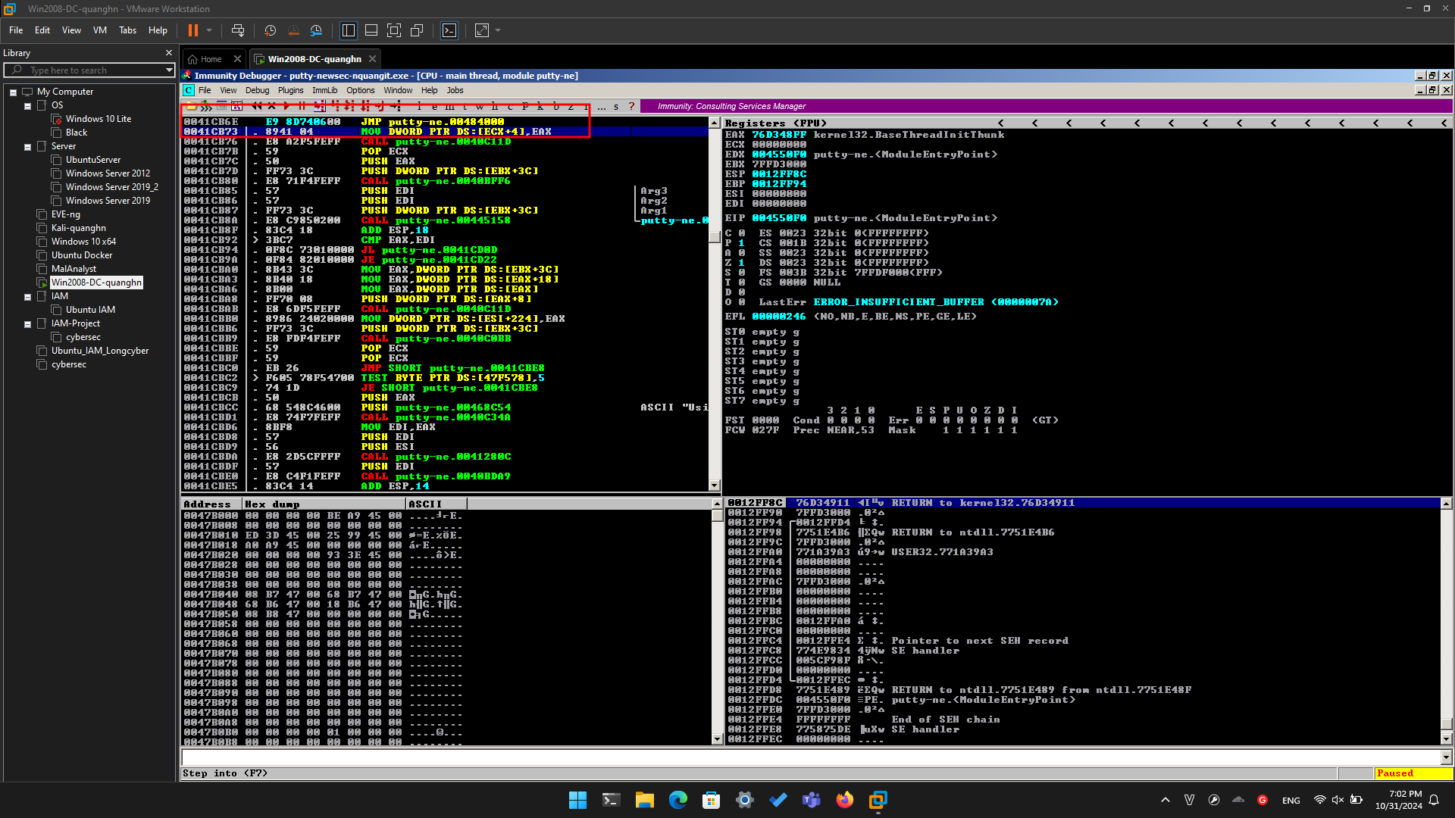

**Adding Trojan Code**

Now we can add extra commands to Putty in ".NewSec". First we'll just put an INT3 there, so we can verify that the redirection works. When the processor executes the INT3 command, the program will stop and show a message in Immunity.

In the JMP insruction, right-click **00484000**. and click **Follow**.

Immunity moves to address 00484000.

Right-click **00484000** and click **Assemble**. Enter this command, as shown below.

**INT3**

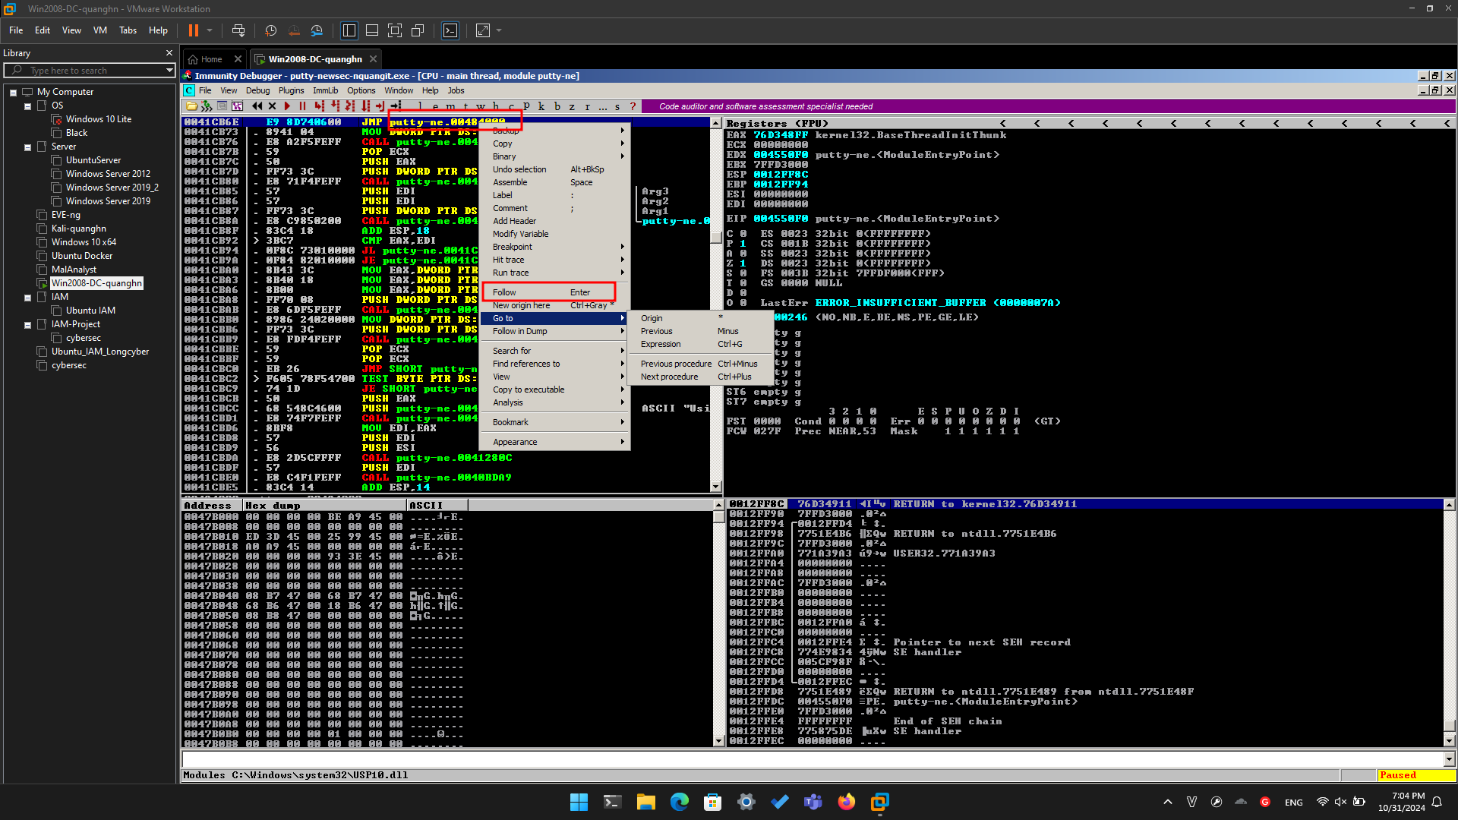

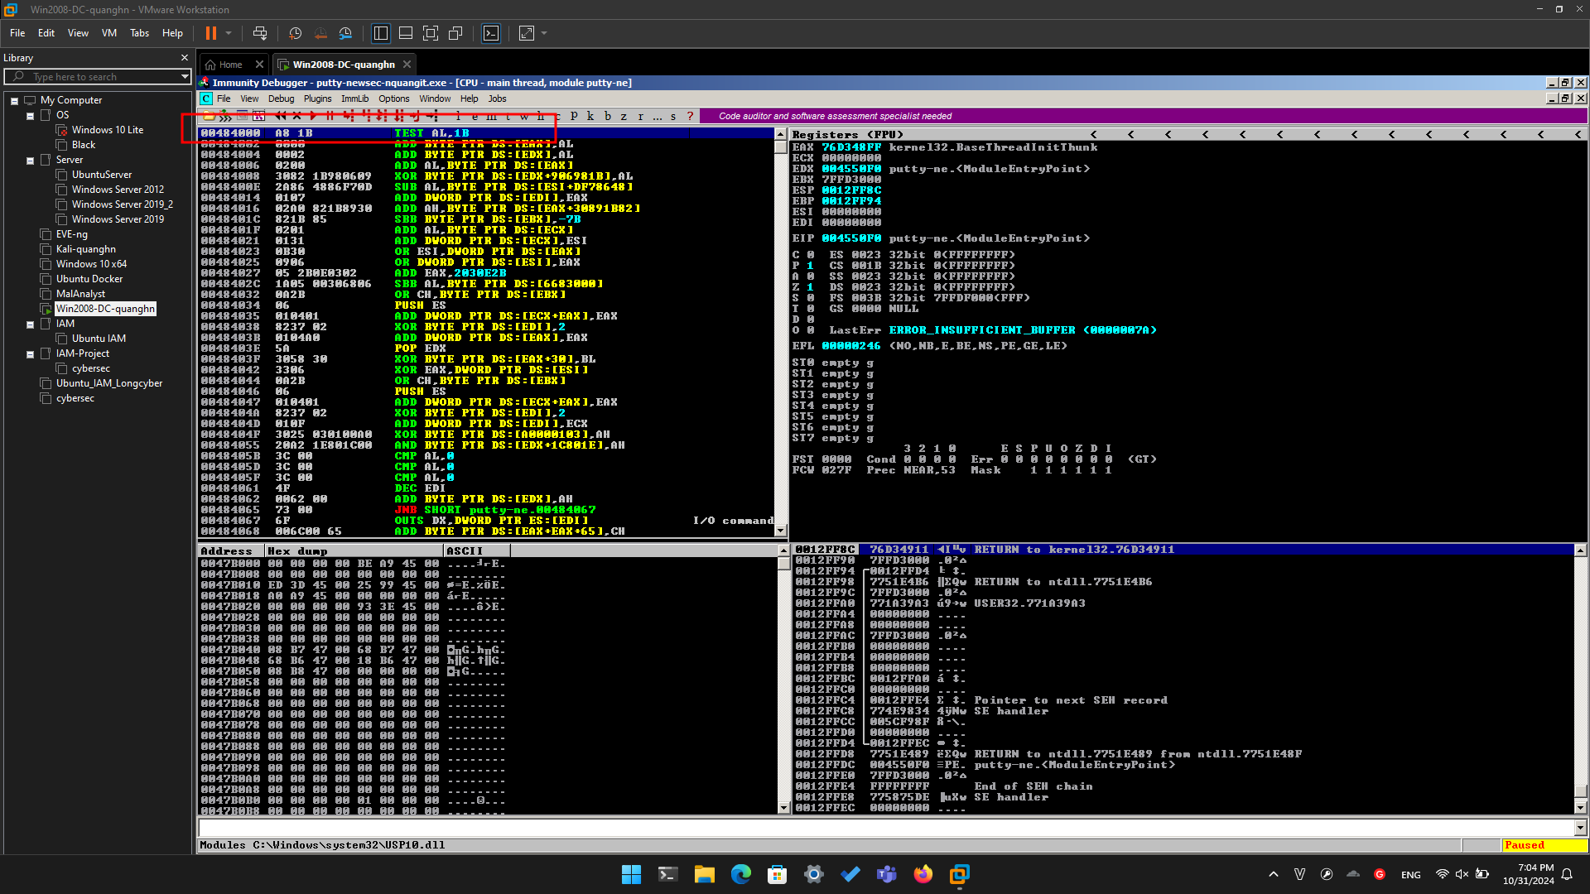

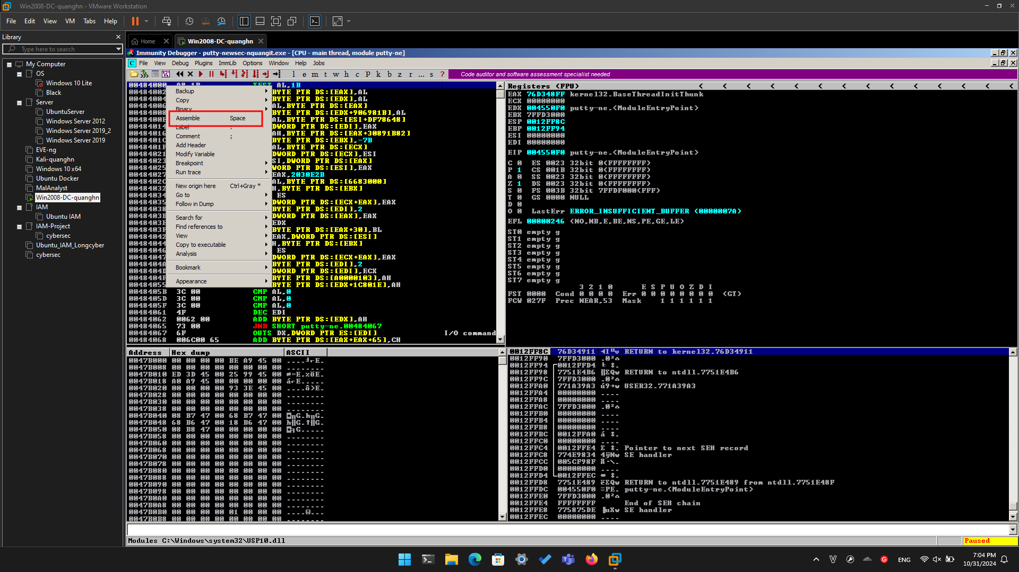

Click **Assemble**. Click **Cancel**.

Address 484000 now contains an INT3 instruction, which is CC in hexadecimal, As shown below.

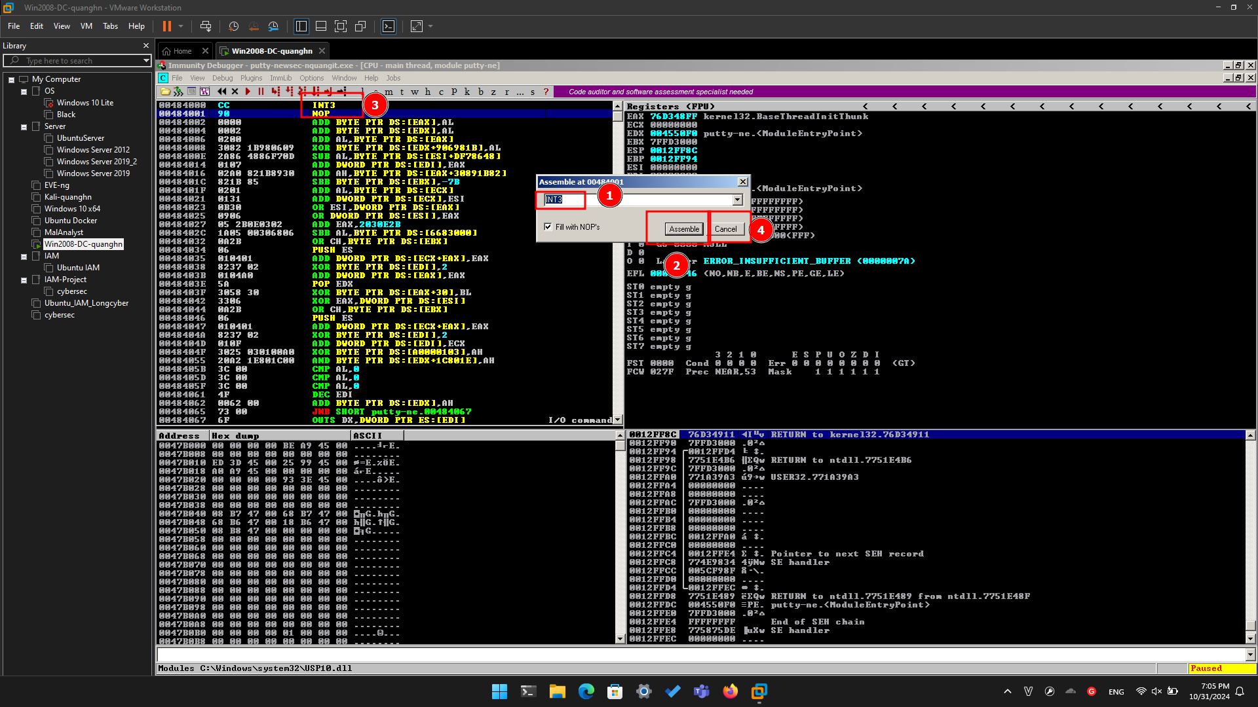

**Running the Modified App in Immunity**

In Immunity, click **Debug**, **Run**.

Putty opens. In the "Host Name (or IP address)" box, type

**ad.samsclass.info**

At the bottom, click the **Open** button.

The program stops, and the status bar at the bottom of the Immunity window says "**INT3 command ...**", as shown below.

This shows that the code redirection worked, and executed the first instruction in the .NewSec section!

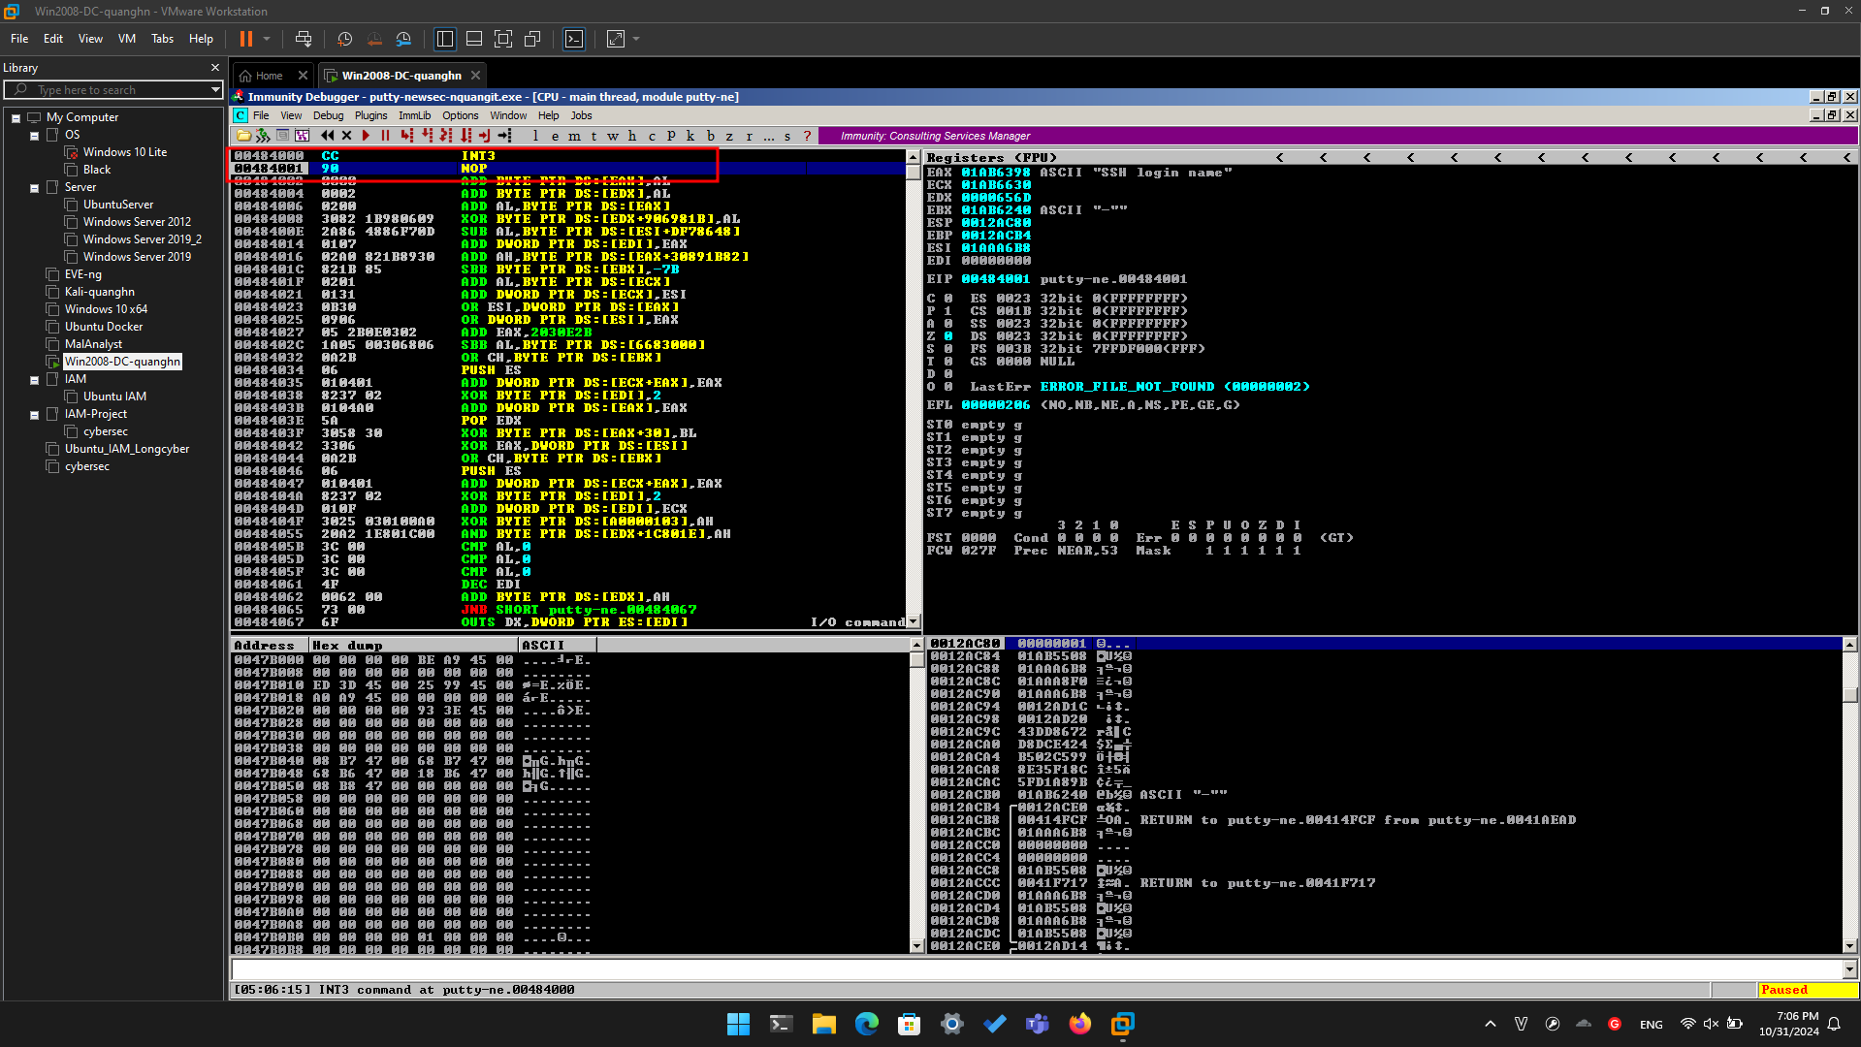

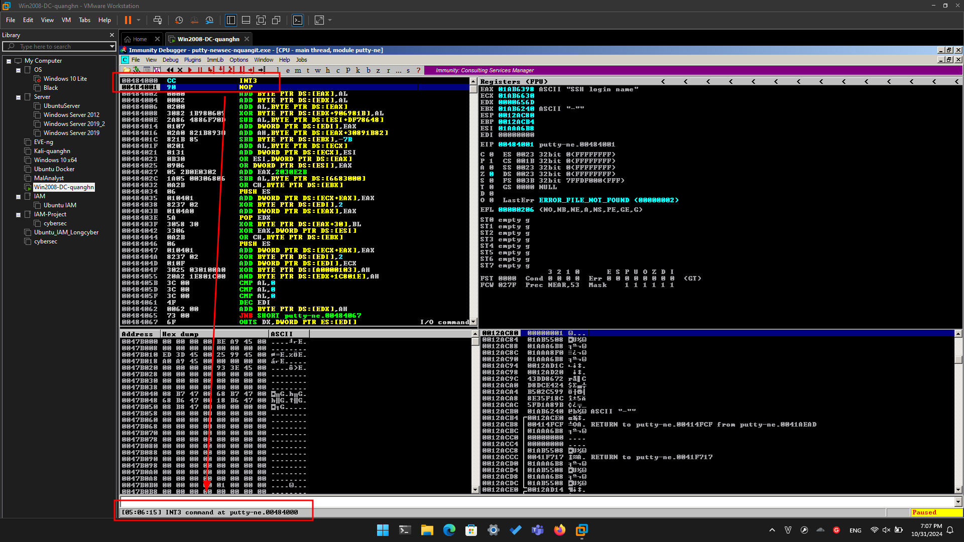

**Task 3: Inserting Real Shellcode**

**Saving the Modified EXE**

In Immunity, maximize the CPU window.

In the top left pane of the CPU window, right-click, and click "**Go to**", **Expression**, as shown below.

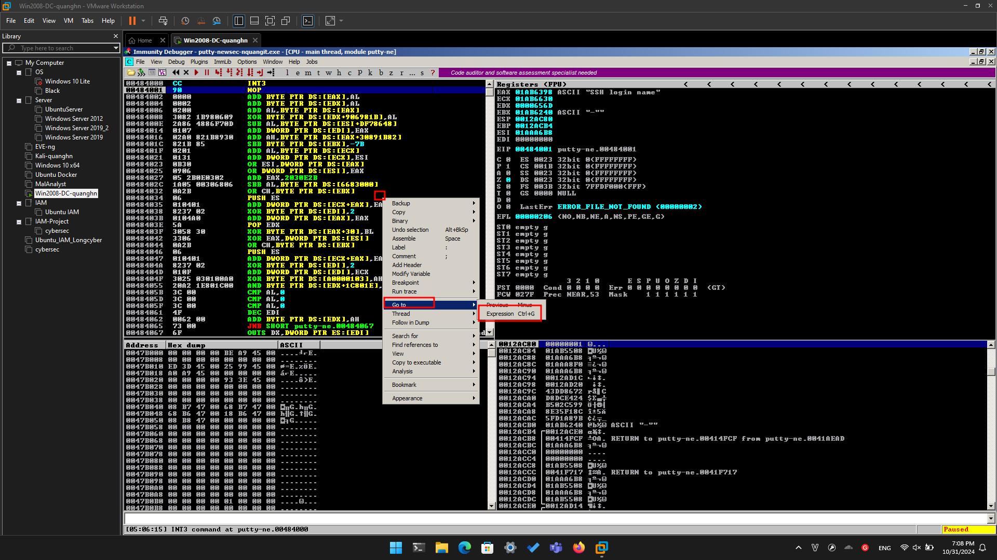

In the "Enter expression to follow" box, enter **41CB6E** as shown below. Click **OK**.

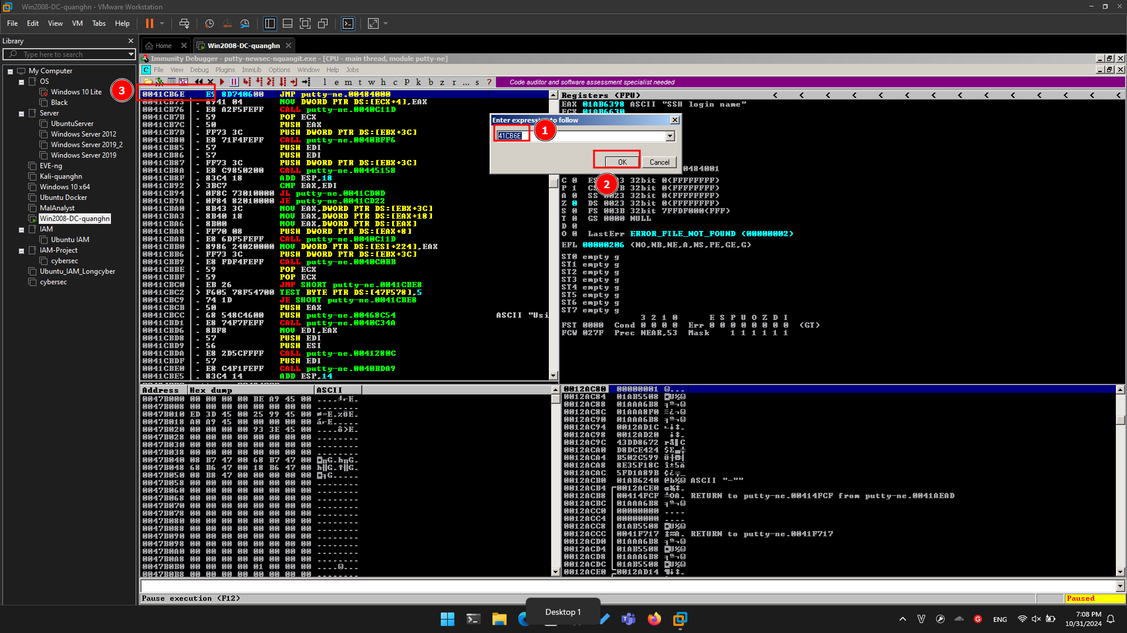

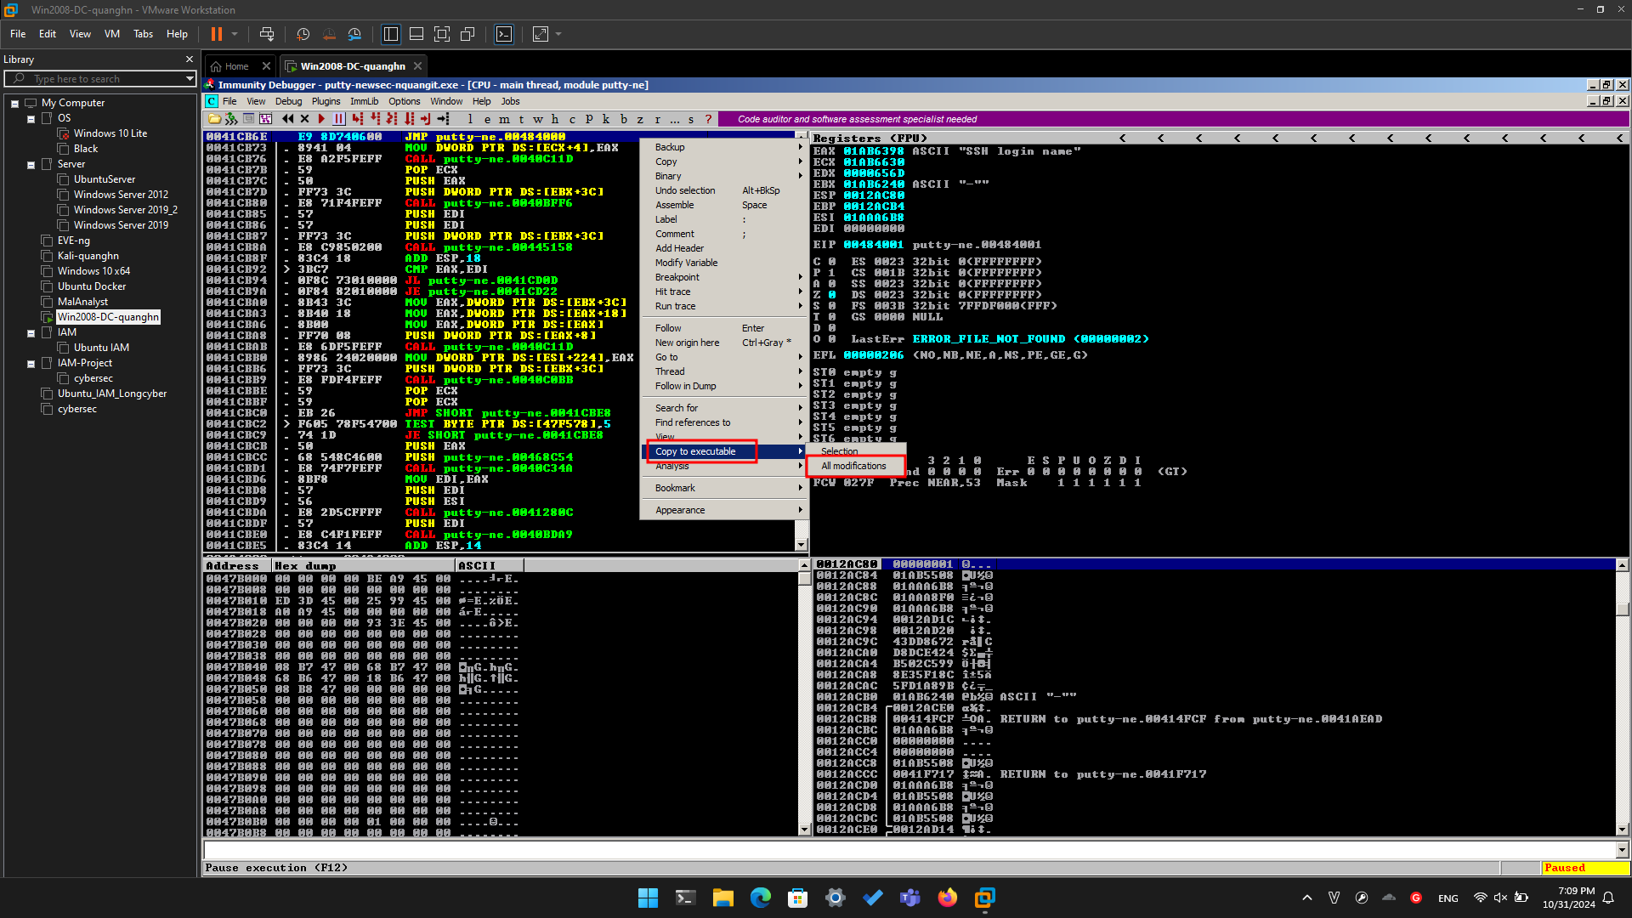

A "Copy selection to executable file" box pops up. Click the "**Copy all**" button.

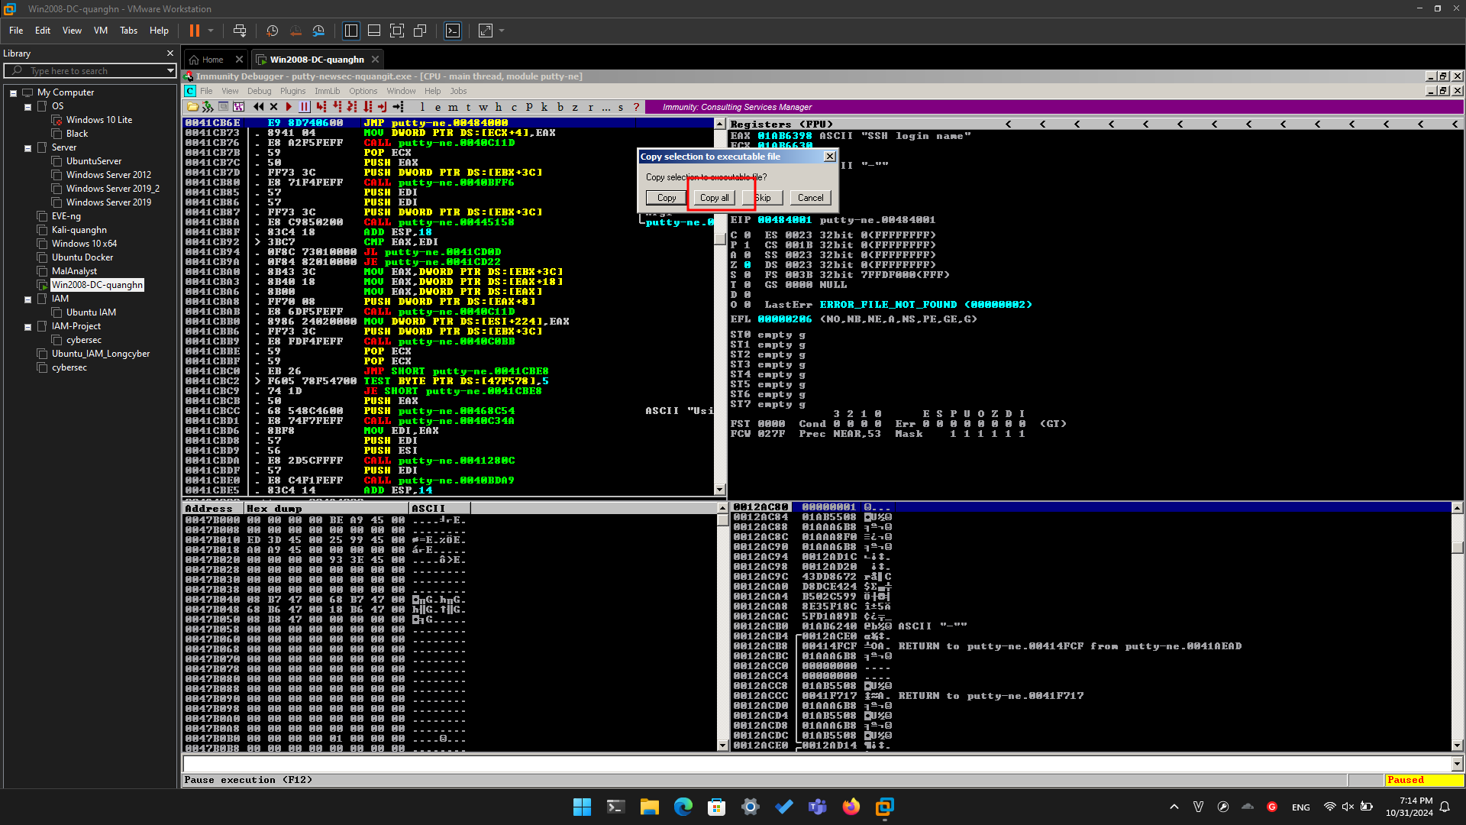

A new window pops up, with a title ending in "putty.exe", as shown below.

Right-click in the new window and click "**Save file**".

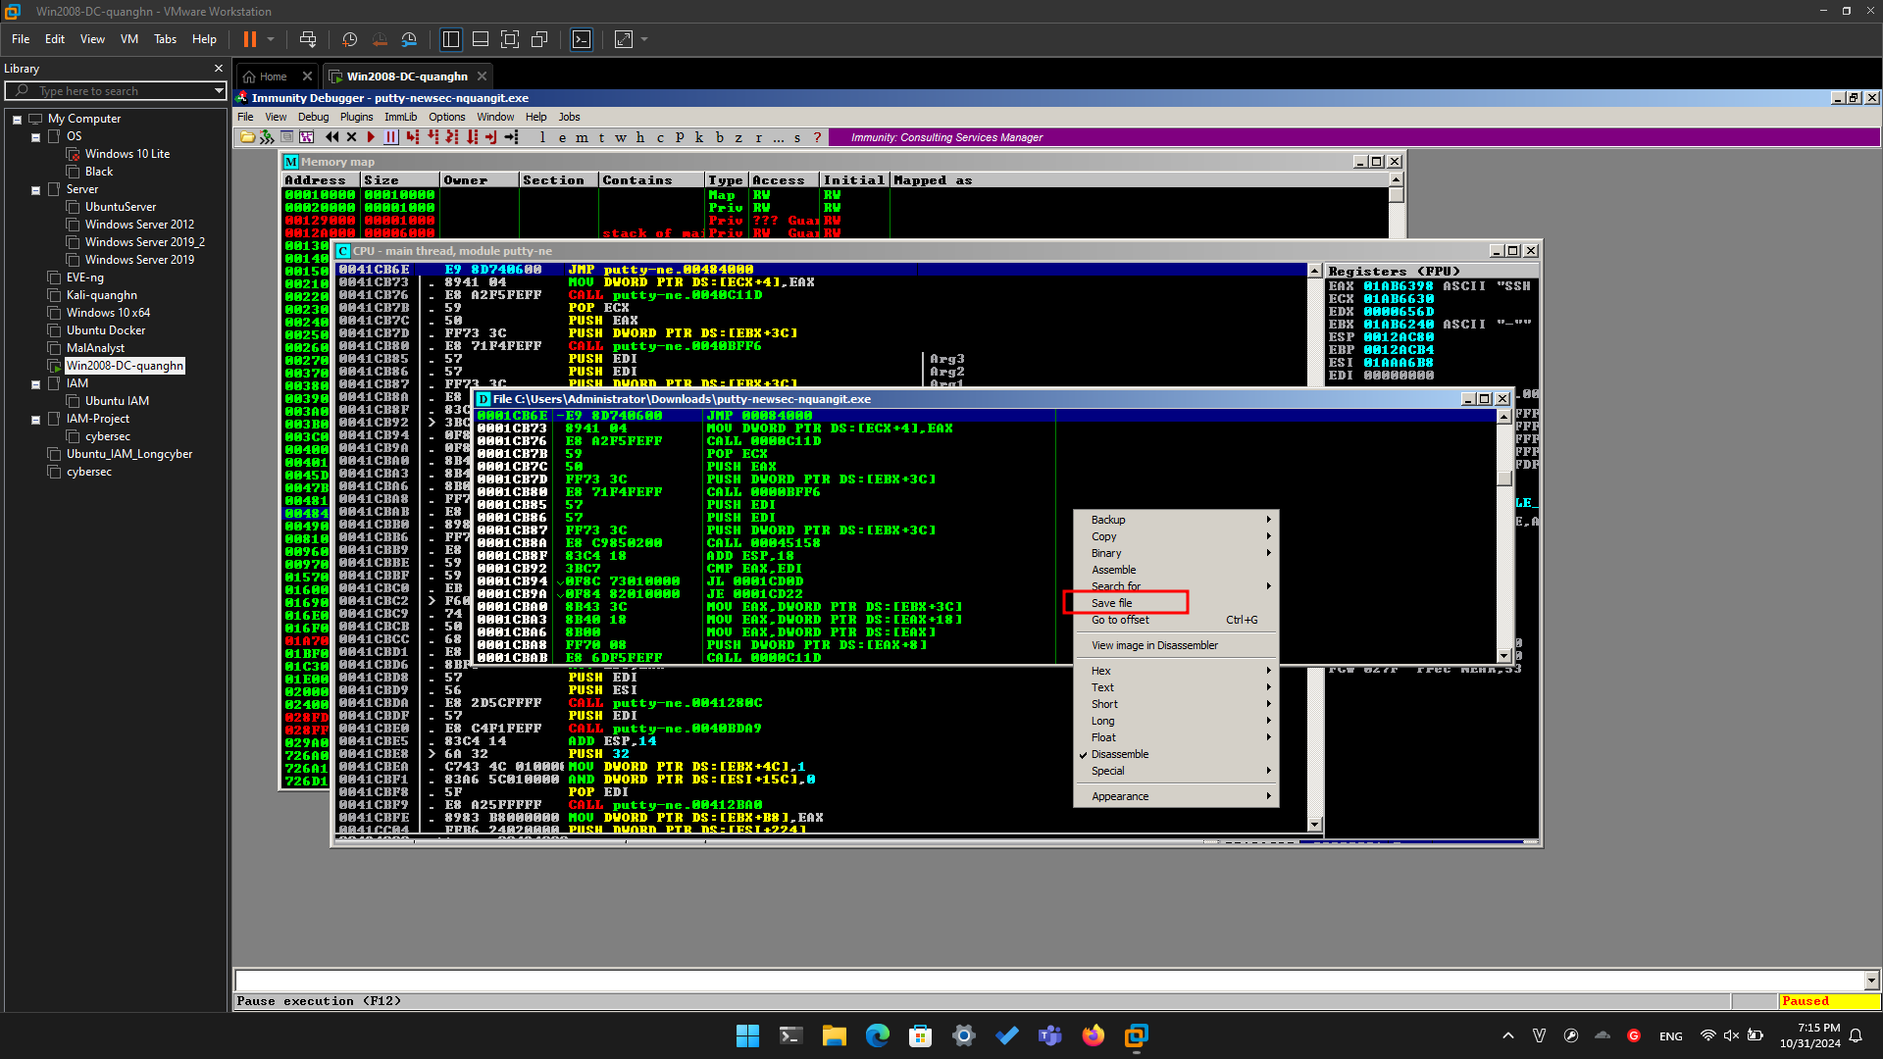

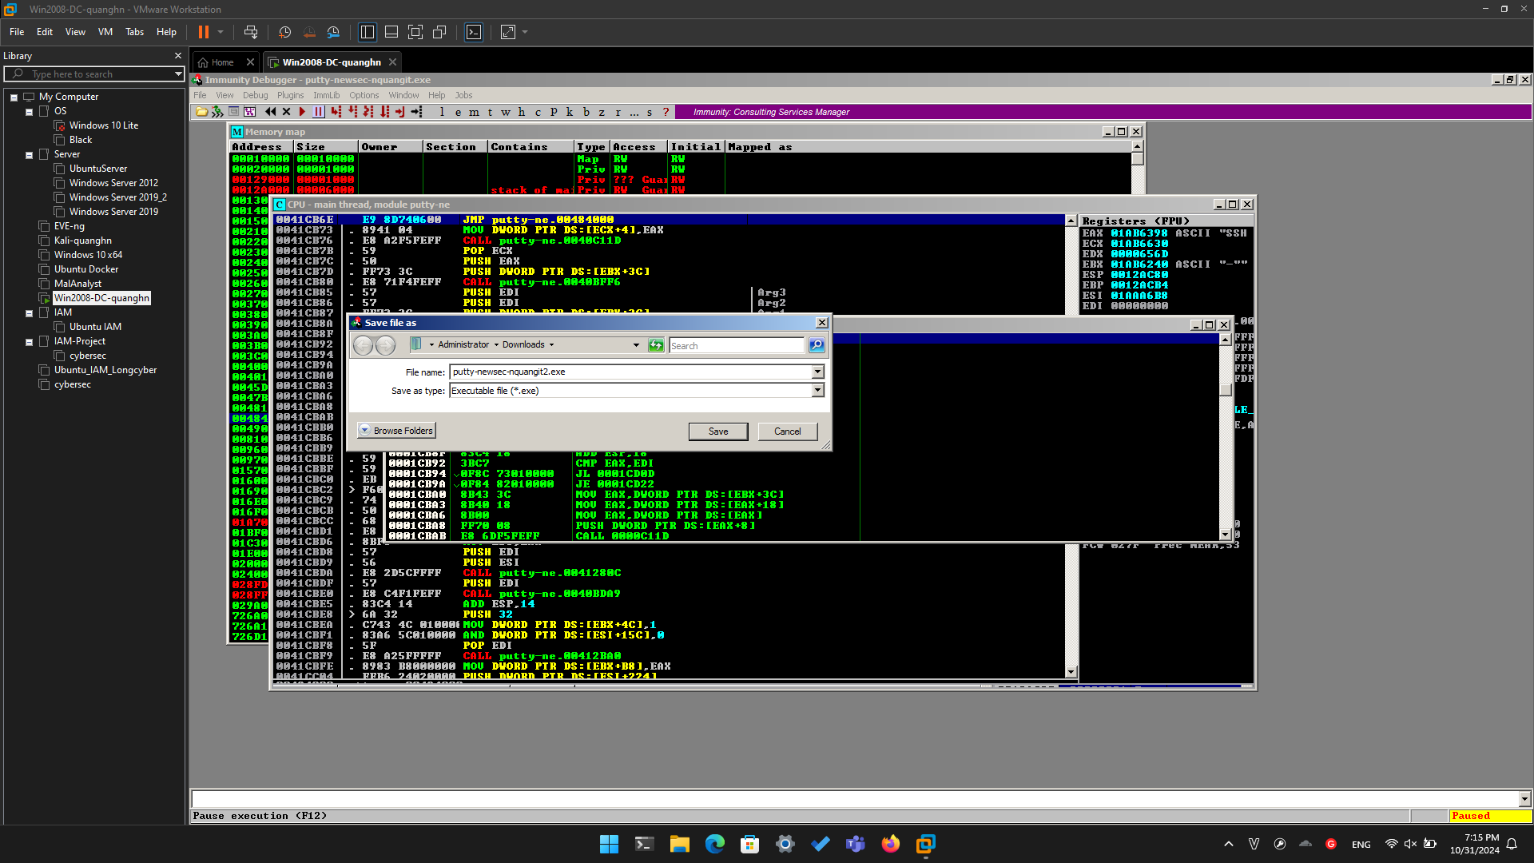

**Getting Simple Shellcode**

**Usually it's best to generate custom shellcode for each attack, and use a reverse shell that calls your Command-and-Control server. But for this project, we'll use a simpler**

**attack, that merely opens a listening port on port 4444. This is a weak attack that can be stopped by any firewall, but it's good enough to practice the exploitation**

**techniques,**

**You can generate shellcode with msfvenom, on Kali. Here's what I got when I did it:**

**root@kali:~/Cminer# msfvenom -p windows/shell_bind_tcp -f c**

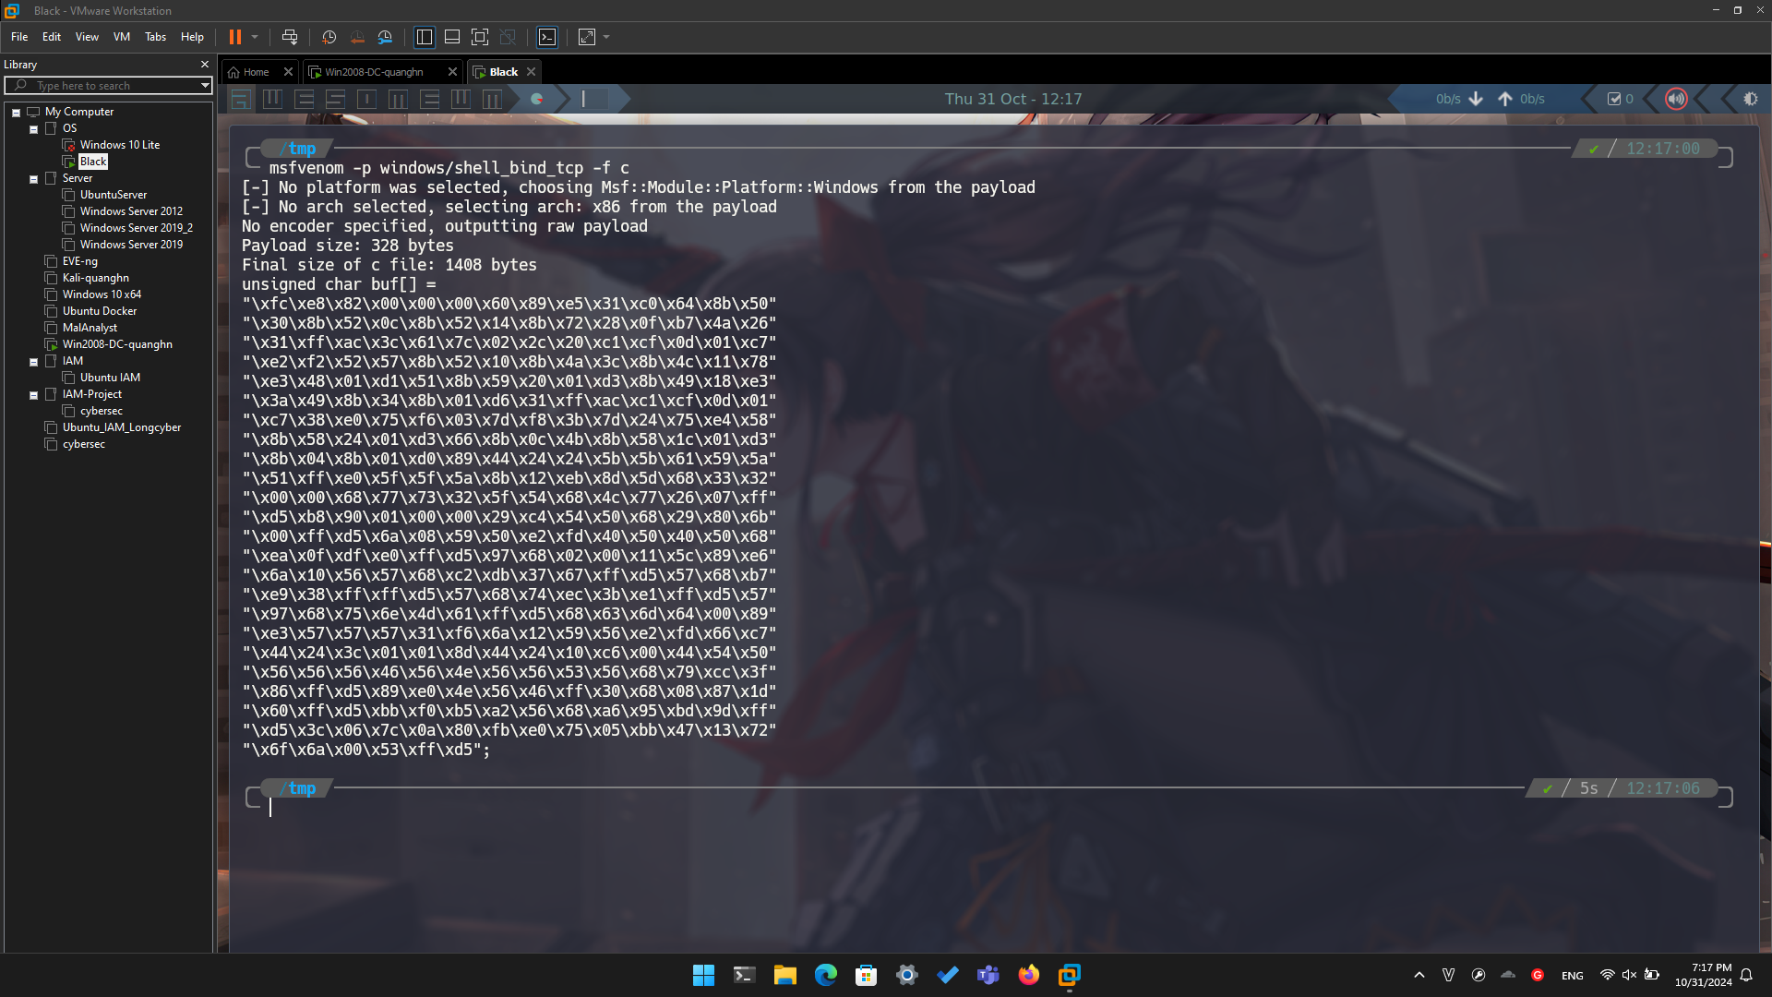

Here's the shellcode, reformatted and broken into two sections.

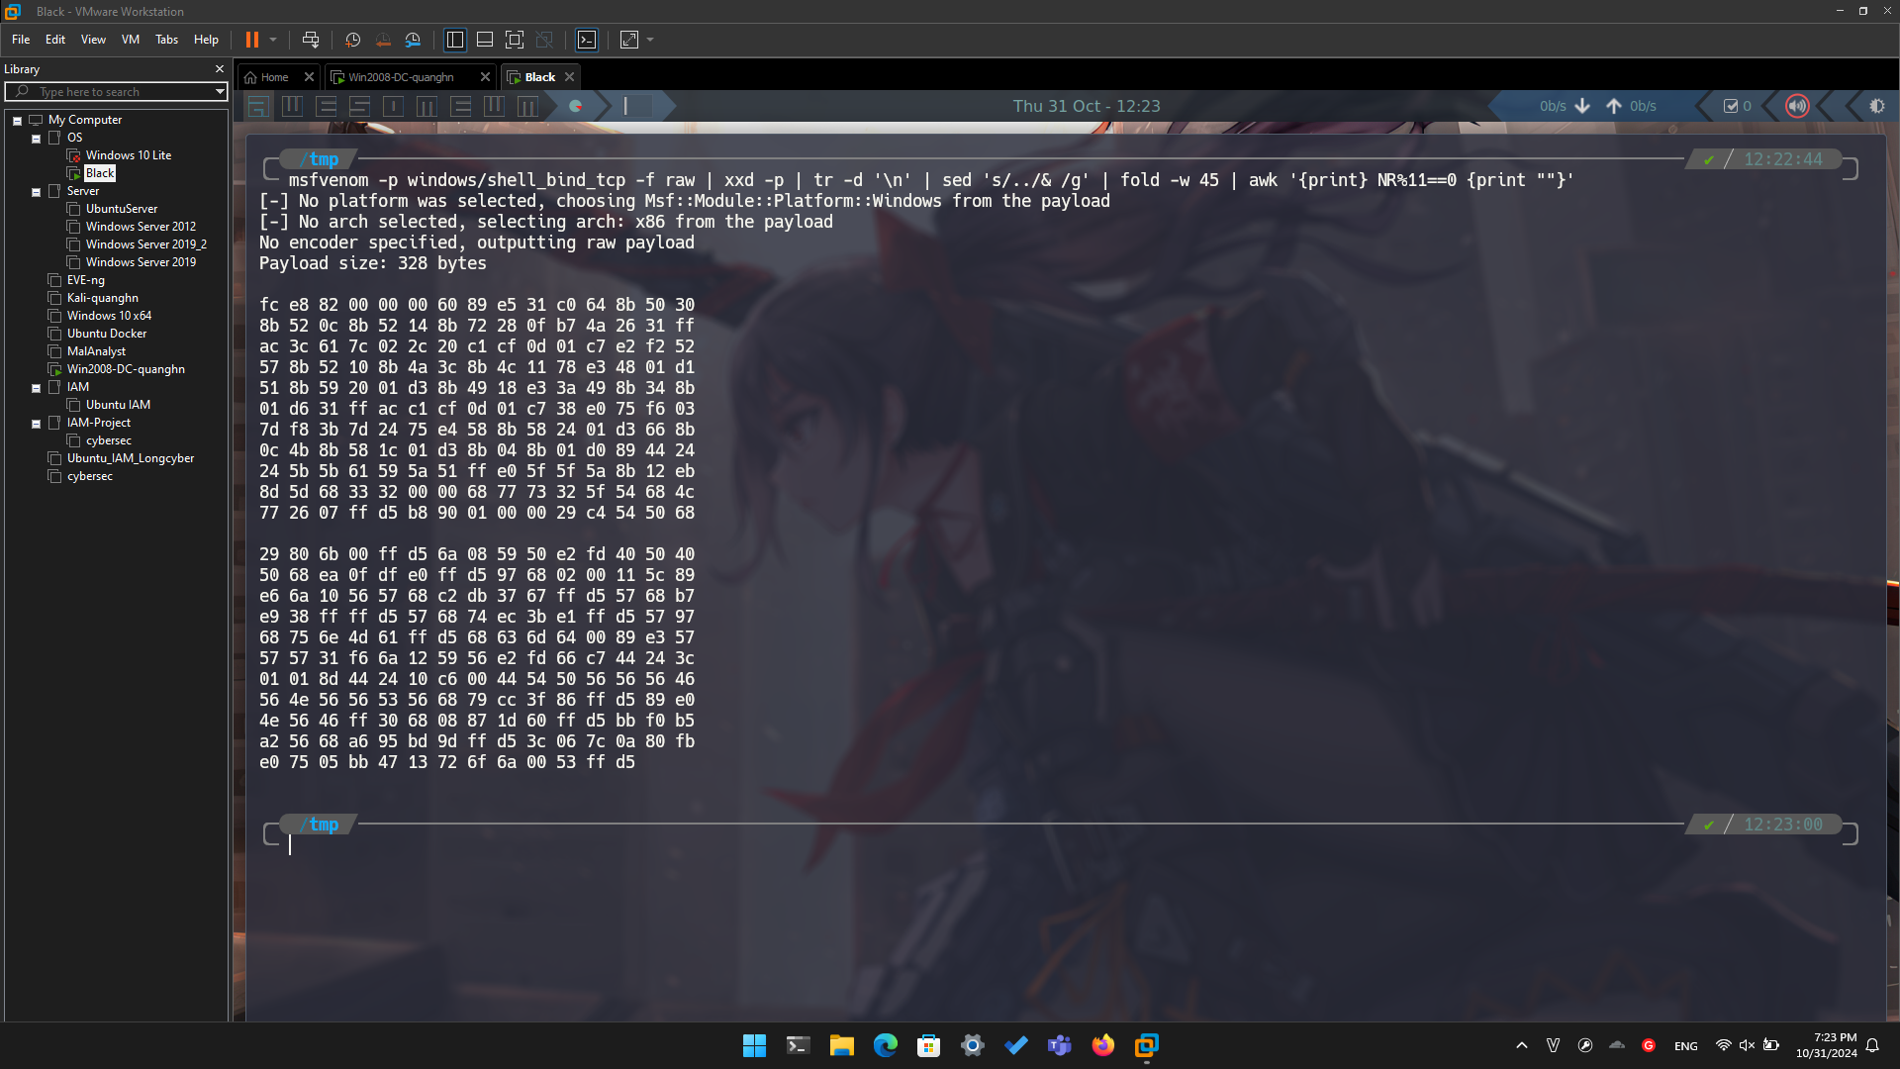

**Inserting Shellcode with HxD**

Open HxD. Click **File**, **Open**. Open **putty-newsec-YOURNAME2.exe**.

Scroll to address 00080000. After a region filled with zeroes, it starts with these bytes: "A8 1B 00", as shown below.

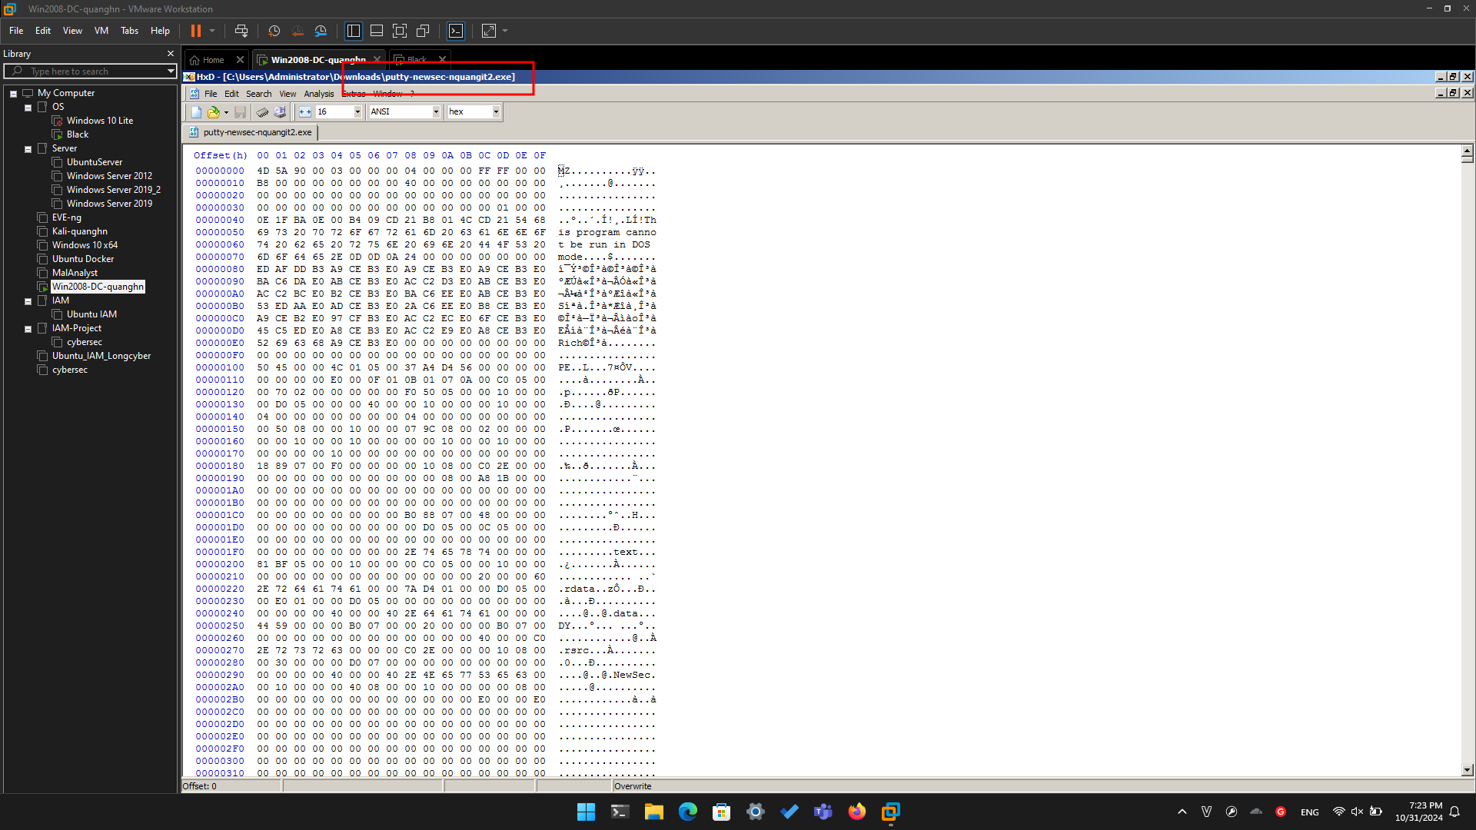

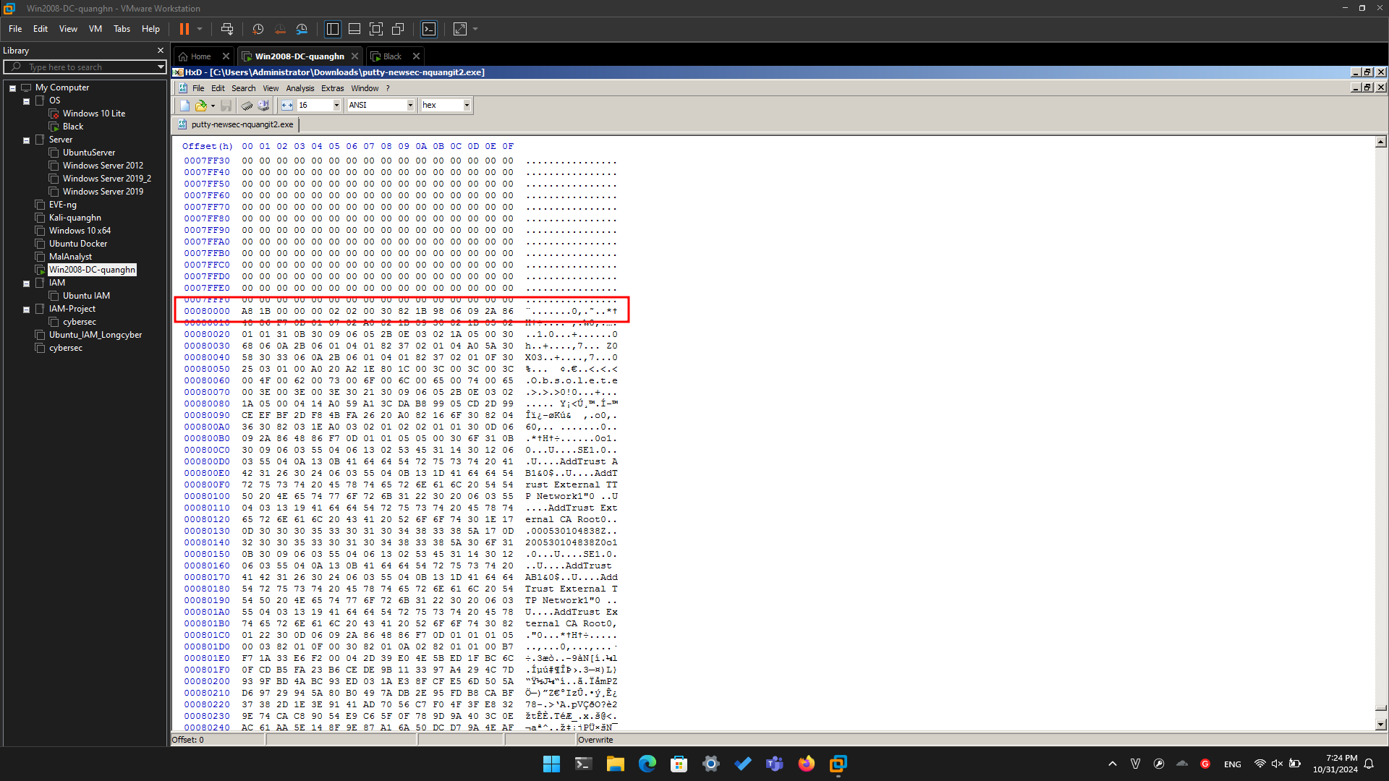

Above, on this Web page, highlight and copy the first set of shellcode bytes, from "fc" through "68".

In HxD, right-click the byte at address 00080000 and click "**Paste write**", as shown below.

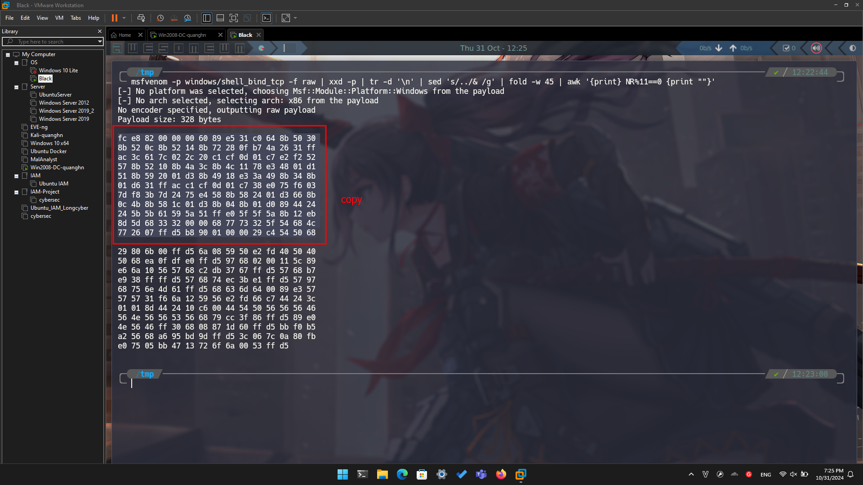

The first portion of the shellcode appears in red text, as shown below.

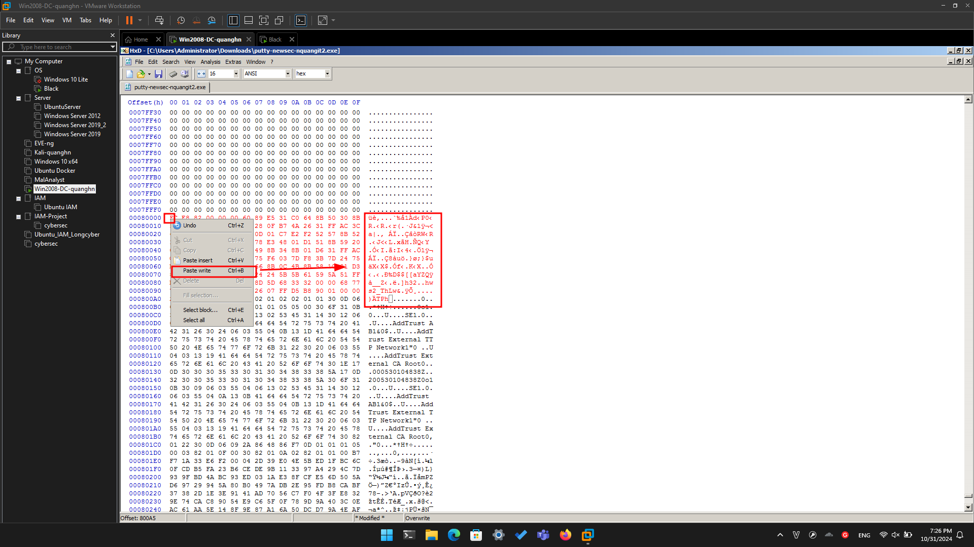

Above, on this Web page, highlight and copy the first set of shellcode bytes, from "29" through "d5".

In HxD, right-click the byte at address 000800A5 and click "**Paste write**". Your screen should look like the image below.

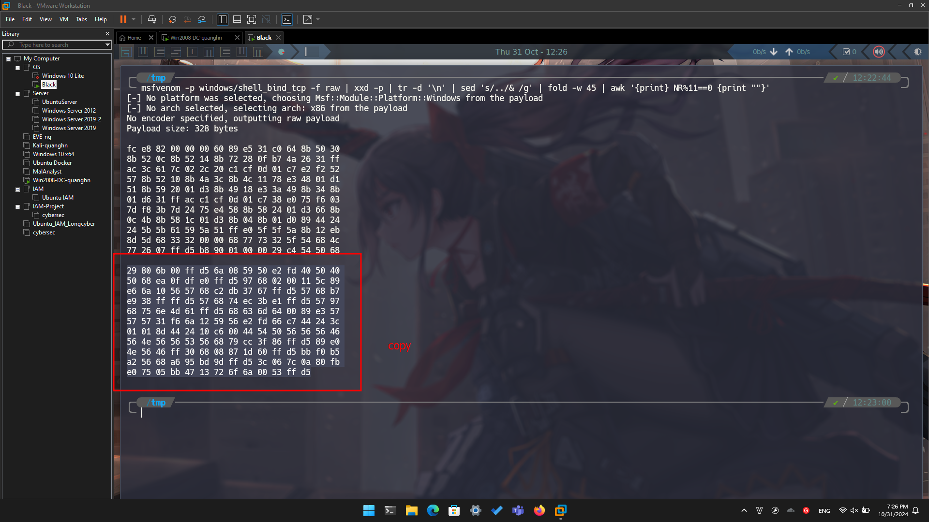

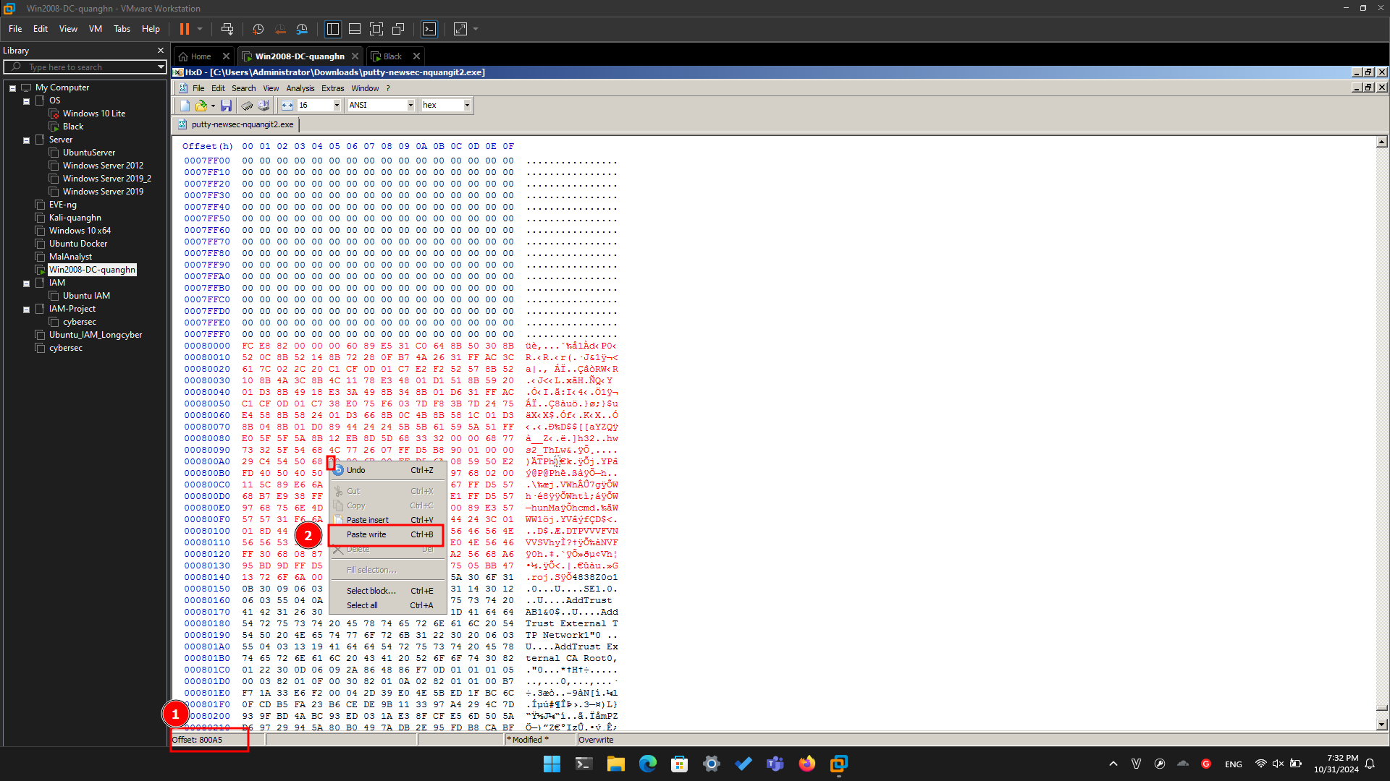

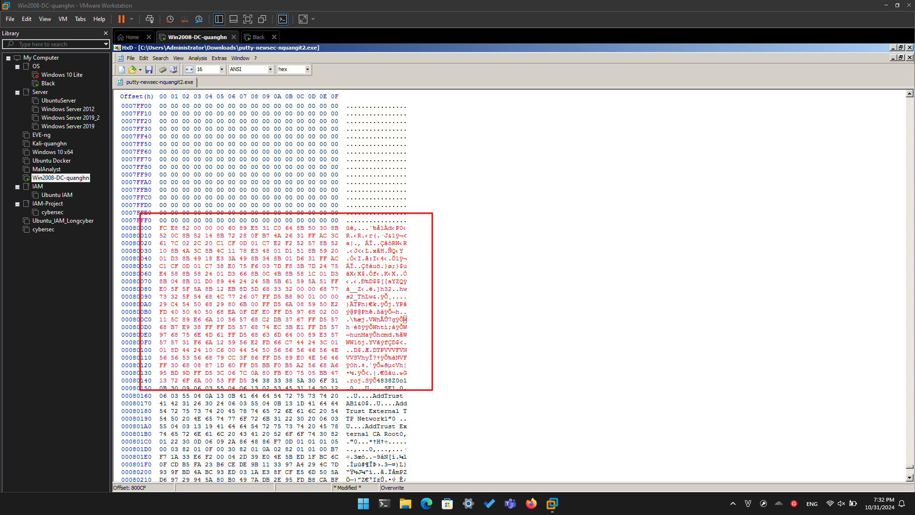

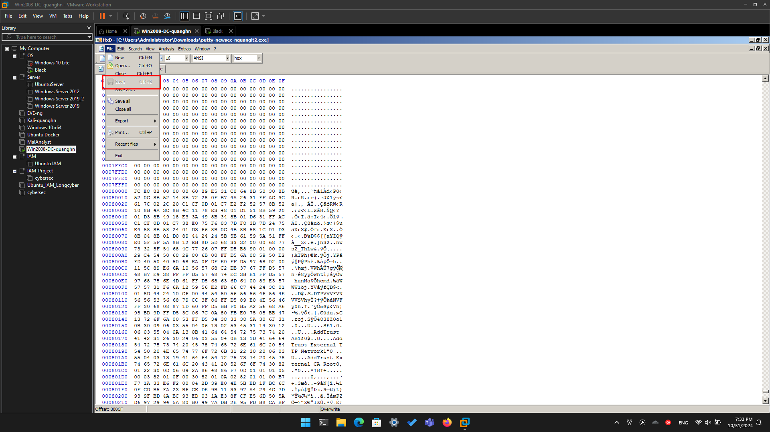

**Running the Trojaned Putty**

Double-click **putty-newsec-YOURNAME2.exe**.

Putty opens. In the "Host Name (or IP address)" box, type

**ad.samsclass.info**

At the bottom, click the **Open** button.

A black Putty window opens, but remains blank, as shown below.

This is because we were sloppy when inserting shellcode, and broke the normal operation of Putty.

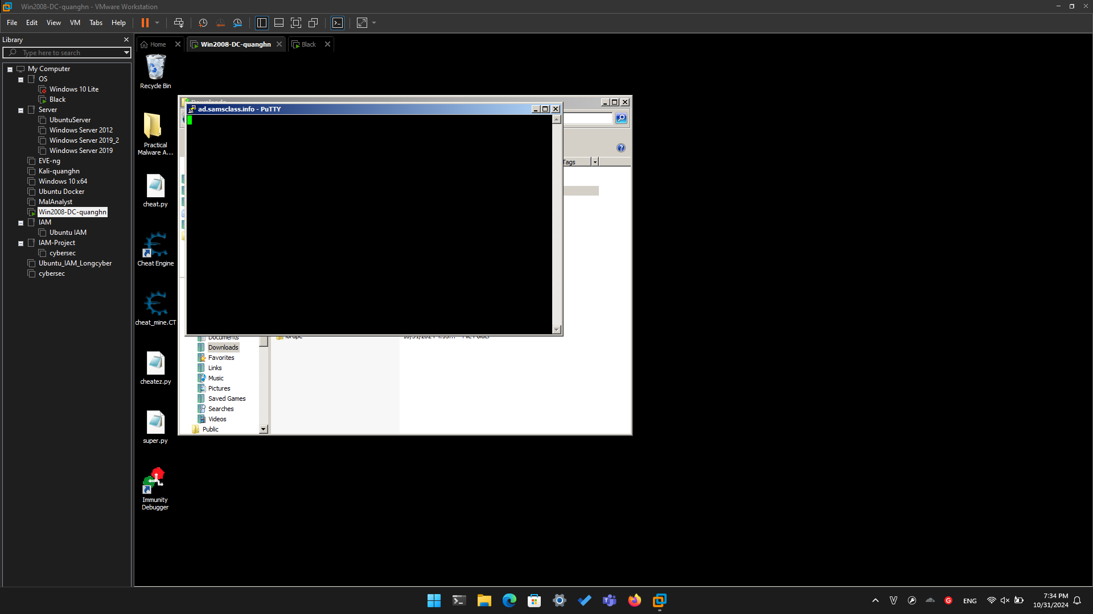

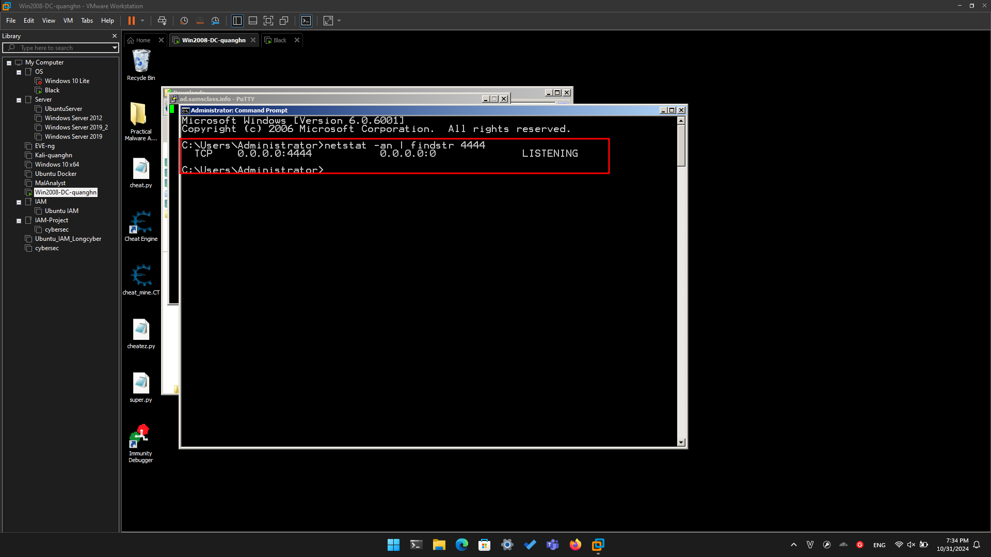

**Connecting to the Target**

Open another Command Prompt window. Execute this command:

**telnet 127.0.0.1 4444**

A Command Prompt opens, allowing you to execute commands on the server, as shown below.

Execute this command:

**whoami**

You are the local administrator, as shown below, and so is anyone else who connects to this machine on port 4444.

